Dinmore station accessibility upgrade

Project update –

September 2016
Preliminary platform raising works are well underway at Dinmore station as part of Queensland Rail’s $212 million station upgrade program.

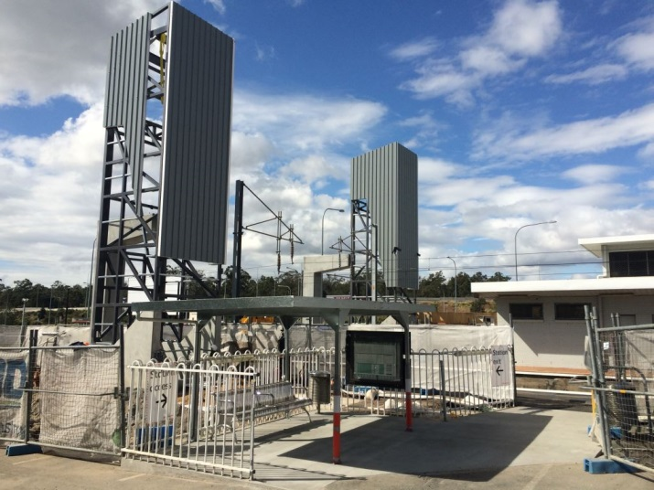

Project progress
The following construction activities were recently completed:
- construction and opening of temporary access ramps between both platforms and carparks
- commencement of platform raising works
- installation of temporary go card touch on/off pedestals.

Upcoming work
In the coming weeks, customers and the community can expect to see the following activities:
- construction of new permanent platform entrances
- platform raising works
- installation of reinforcing and concreting works
- installation of scaffolding and steel members for new stairs.

Other changes at the station
Temporary changes to customer parking will be in effect between Monday 26 September and Friday 7 October 2016. More information and maps of affected areas are available at the station.
Station upgrade work will take place on the platforms during a planned track closure over the Queen’s Birthday weekend, Saturday 1 to Monday 3 October 2016. Ticketing equipment will be available and the footbridge will remain open to pedestrians during these works.

Construction impacts
Customers and residents adjacent to Dinmore station may experience:
- noise associated with heavy machinery
- use of reversing beepers
- mobile lighting towers for night works
- changed traffic and parking conditions
- increased vehicle movements around the work zone.
Pedestrians are asked to follow all directional signage during this time.
Nearby residents and other stakeholders will be given advance notification of construction activities likely to cause impacts, including after-hours work (nights and Sundays, if required).

Keeping you informed
For more information on this project, please contact the Stakeholder Engagement team on 1800 722 203 (free call), email stationsupgrade@qr.com.au or visit www.queenslandrail.com.au

