Dinmore station accessibility upgrade

Access and parking changes – July 2016
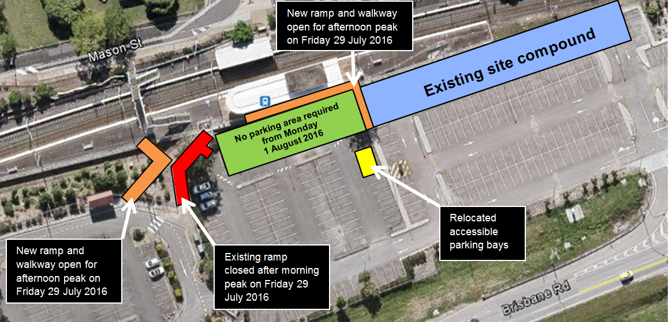

From Friday 29 July 2016, access and parking conditions will change at Dinmore station to allow upgrade work to commence on existing access ramps and behind the central section of platform 1.

Access and parking changes
- Friday 29 July 2016 after the morning peak:
- the existing access ramp from the Brisbane Road carpark to platform 1 will close
- a temporary access ramp will be opened near the existing pick-up and drop-off zone and bus shelter at the River Road end of the platform
- a new permanent ramp will open adjacent to the station building to align with the new footbridge and lifts currently under construction (please see image above).

- Monday 1 August 2016:
- the parking spaces behind the station building will be required for construction
- accessible parking bays will be relocated (please see image above).

The go card touch on/touch off equipment will be relocated. Temporary access ramp fencing will be installed for safety. Please follow all directional signage and take care around works.

Keeping you informed
Queensland Rail is committed to keeping stakeholders and the community informed about this project. For more information, please contact the Stakeholder Engagement team on 1800 722 203 (free call), email stationsupgrade@qr.com.au or visit www.queenslandrail.com.au

