Graceville station accessibility upgrade

Project update –

August 2016
Station accessibility upgrade works are progressing at Graceville station as part of Queensland Rail’s $212 million upgrade program.

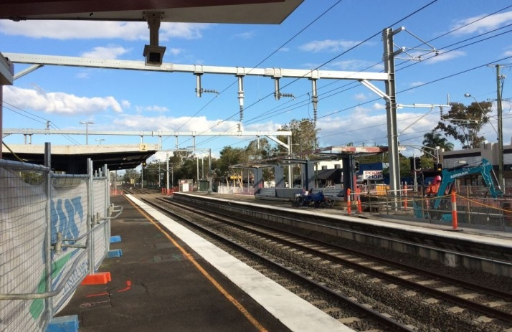

Project progress
The following construction activities were recently completed:
- preliminary foundation works for new lift shafts
- commenced excavation for new stairs on platforms 3 and 4
- installed new conduits and underground service pits
- upgraded overhead equipment.

Upcoming work
In the coming weeks, customers and the community can expect to see the following construction activities:
- excavation works for new lift shafts
- concrete pours for new lightpole footings and new stairs
- modification of subway walls to allow for new stair and lift access points.
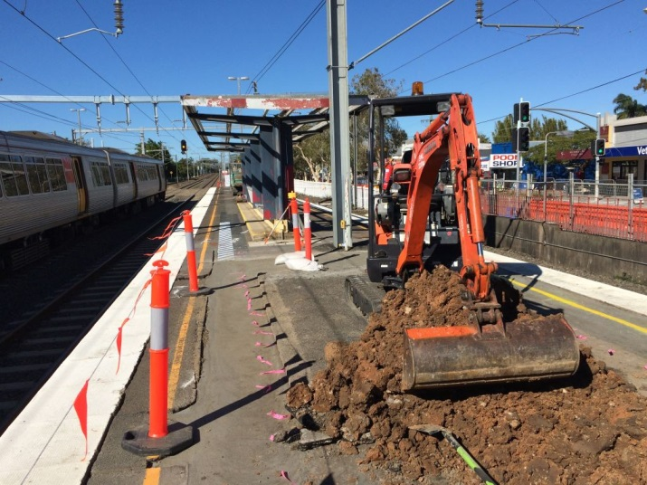
- commencement of removal of existing stairs on platforms 3 and 4 in preparation for new lift shaft construction.

Construction impacts
Customers, residents and businesses adjacent to Graceville station may experience the following:
- noise associated with heavy machinery
- use of reversing beepers
- changed traffic and parking conditions
- mobile lighting towers for night works
- increased vehicle movements near works
- temporary changes to access paths throughout the station precinct.
Pedestrians and motorists are advised to follow all directional signage during this time.
Residents and other stakeholders will be given advance notification of construction activities likely to cause impacts, including after-hours work (nights and Sundays, as required).

Keeping you informed
For more information on this project, please contact the Stakeholder Engagement team on 1800 722 203 (free call), email stationsupgrade@qr.com.au or visit www.queenslandrail.com.au

