Graceville station accessibility upgrade

Project update –

September 2016
Work is progressing at Graceville station as part of Queensland Rail’s $212 million upgrade program.

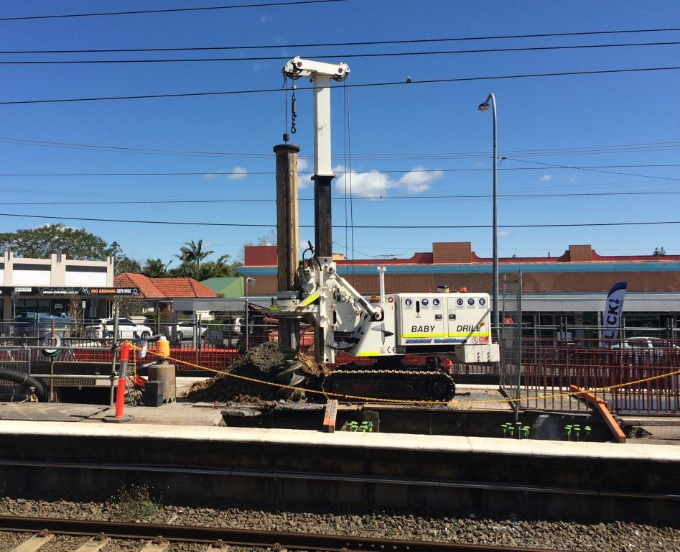

Project progress
The following construction activities were recently completed:
- Removed original stairs on platforms 3 and 4 in preparation for lift shaft construction
- excavation works for new lift shafts
- commenced concrete cutting to modify subway walls for new stair and lift access
- poured concrete for new light pole footings.
Recently, the team undertook testing of concrete cutting methods in the subway to minimise the impact on residents and customers. The use of sound-dampening materials to insulate the work zone has enabled concrete cutting to occur during normal daytime station operations, reducing excessive noise at night.

Upcoming work
In the coming weeks, customers and the community can expect to see the following:
- further work on lift entrances in subway
- continuing excavation works for new lift shafts
- concrete pours for new stairs and lift shafts
- night works (Sunday to Thursday nights through September and October).
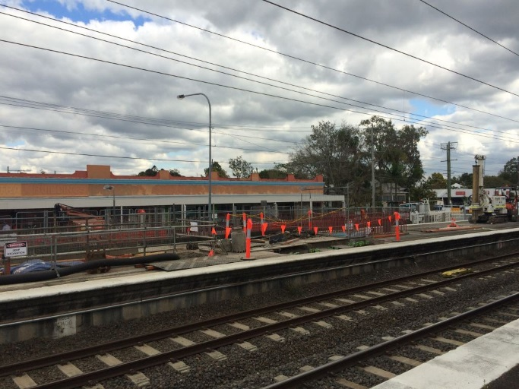

Construction impacts
Customers, residents and businesses adjacent to Graceville station may experience the following:
- noise associated with heavy machinery
- use of reversing beepers
- changed traffic and parking conditions
- mobile lighting towers for night works
- increased vehicle movements near works
- temporary changes to access paths throughout the station precinct.
Pedestrians and motorists are advised to follow all directional signage during this time.
The local community will be given advance notification of construction activities likely to cause impacts, including after-hours work (nights and Sundays, as required).

Keeping you informed
For more information on this project, please contact the Stakeholder Engagement team on 1800 722 203 (free call), email stationsupgrade@qr.com.au or visit www.queenslandrail.com.au

