Nambour station accessibility upgrade

Project update –

September 2016
Upgrade works on the platforms and in the subway are well underway at Nambour station as part of Queensland Rail’s $212 million upgrade program.

Project progress
The following construction activities were recently completed:
- removal of part of the station building roof
- installation of new mast and overhead electrification lines
- demolition of concrete structures in the subway and on the platforms
- installation of new platform awning roofing
- installation of light poles at the southern end of the platform
- pouring of concrete in subway and lift well
- platform surfacing.
Platform access has now changed for the next stage of works.
Please follow all directional signage and take care around work zones.

Upcoming work
In the coming weeks, customers and the community can expect to see the following construction activities:
- further demolition of concrete structures
- ongoing works in subway
- construction works in station building and new public toilets
- continuing lift well works
- buffer stop works
- ongoing upgrade of platform 1.
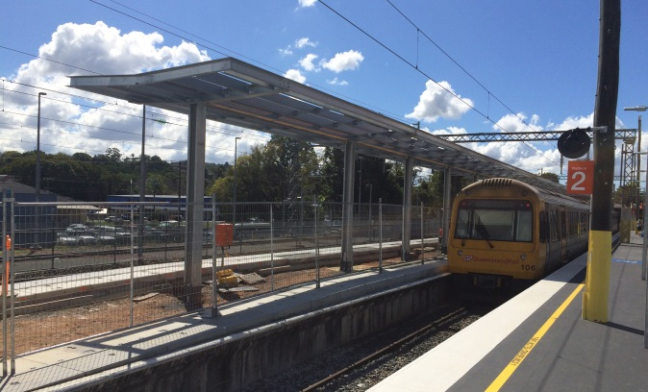

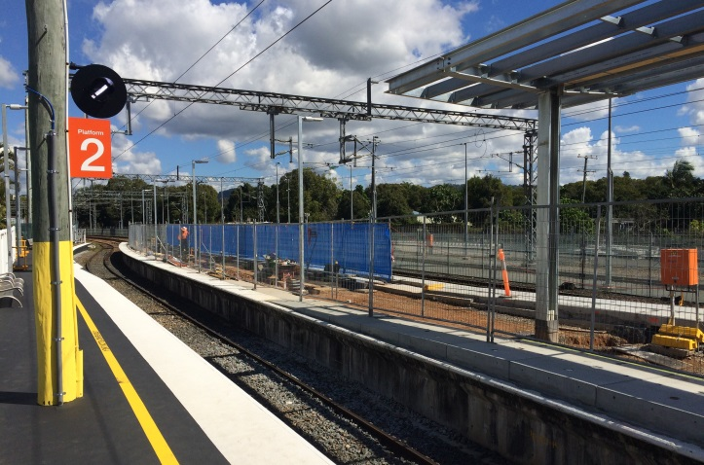

Construction impacts
Customers, residents and businesses adjacent to Nambour station may experience the following:
- noise associated with heavy machinery
- use of reversing beepers
- changed traffic and parking conditions
- mobile lighting towers for night works
- increased vehicle movements around the work zones.
Residents and other stakeholders will be given advance notification of construction activities likely to cause impacts, including after-hours work (nights and Sundays, as required).
Queensland Rail thanks you for your patience during these important works.

Keeping you informed
For more information on this project, please contact the Stakeholder Engagement team on 1800 722 203 (free call), email stationsupgrade@qr.com.au or visit www.queenslandrail.com.au

