Road closure and night works
Alma Road, Dakabin
Tuesday 10 and Wednesday 11 October 2017
7pm to 5am (each night)

As part of Queensland Rail’s Bridge Strike Protection Program, Alma Road, Dakabin (between Narangba Road and Thompson Road) will be closed each night on Tuesday 10 and Wednesday 11 October for the installation of a protection beam at the rail bridge.
During this time, traffic management including detour signage will be in place to direct road users and pedestrians around the closure:
- Southern detour: via Thompson Road-Ann Street-Marsden Road-Narangba Road
- Northern detour: via Narangba Road-Boundary Road-Old Gympie Road-Alma Road.
Motorists are requested to follow the instructions of the traffic controllers and drive to the changed conditions.
Residents adjacent to the works may experience some noise from the operation of plant and equipment, construction activities and truck movements during these works. Lighting towers will be used on site overnight.
Every effort will be made to carry out these works with minimal disruption.
Queensland Rail apologises for any inconvenience and appreciates the local community’s cooperation during these important works.
For traffic management enquiries, please contact JF Hull on 0437 718 216.
For more information about the Bridge Strike Protection Program contact the stakeholder engagement team on 13 17 16 (8am to 5pm Monday to Friday) or email communityengagement@qr.com.au

Alma Road closure – Tuesday 10 and Wednesday 11 October 2017, 7pm to 5am (each night)
There are two diversion routes, depending on your direction of travel:
- Southern direction (Detour A): via Thompson Road-Ann Street-Marsden Road-Narangba Road
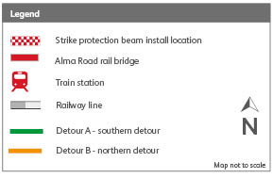
- Northern direction (Detour B): via Narangba Road-Boundary Road-Old Gympie Road-Alma Road.

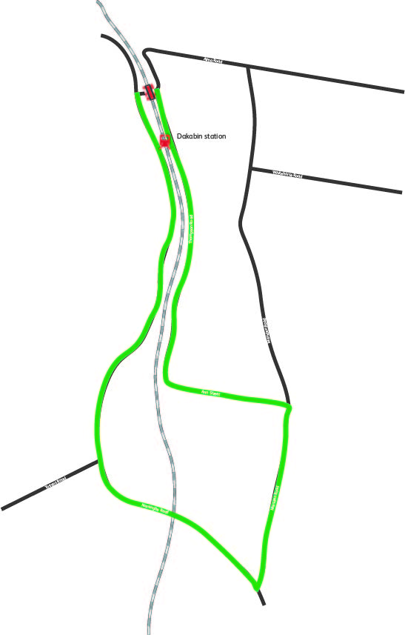

Alma Road

ROAD CLOSURE
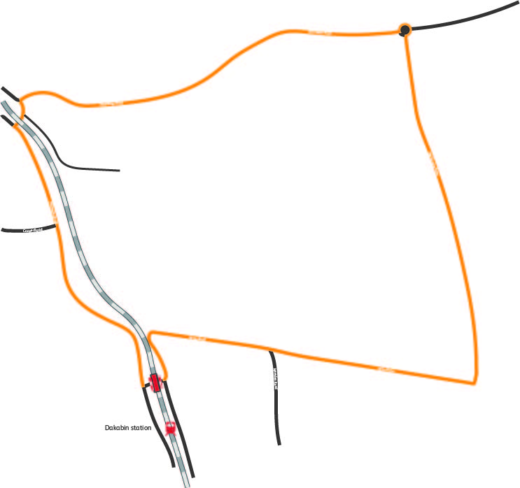

Boundary Road
Thompson Road
Detour A – Southern
ROAD CLOSURE
Narangba Road
Alma Road
Old Gympie Road
Marsden Road
Narangba Road
Narangba Road
Ann Street
Detour B – Northern

