Road closure and night works
Alma Road, Dakabin
Monday 20 to Thursday 23 November 2017
8pm to 5am (each night)

As part of Queensland Rail’s Bridge Strike Protection Program, Alma Road, Dakabin (between Narangba Road and Thompson Road) will be closed over four nights from Monday 20 to Thursday 23 November for the installation of CCTV communications cabling and equipment on the Alma Road rail bridge.
During this time, traffic management including detour signage will be in place to direct road users and pedestrians around the closure:
- Southern detour: via Thompson Road-Ann Street-Marsden Road-Narangba Road
- Northern detour: via Narangba Road-Boundary Road-Old Gympie Road-Alma Road.
Motorists are requested to follow the instructions of the traffic controllers and drive to the changed conditions.
Residents adjacent to the works may experience some noise from the operation of plant and equipment, construction activities and truck movements during these works. Lighting towers will be used on site overnight.
Every effort will be made to carry out these works with minimal disruption.
Queensland Rail apologises for any inconvenience and appreciates the local community’s cooperation during these important works.
For traffic management enquiries, please contact Civforce on (07) 3821 4522.
For more information about the Bridge Strike Protection Program contact the stakeholder engagement team on 13 17 16 (8am to 5pm Monday to Friday) or email communityengagement@qr.com.au

Alma Road closure – Monday 20 to Thursday 23 November 2017, 8pm to 5am (each night)
There are two diversion routes, depending on your direction of travel:
- Southern direction (Detour A): via Thompson Road-Ann Street-Marsden Road-Narangba Road
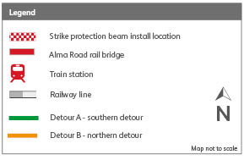
- Northern direction (Detour B): via Narangba Road-Boundary Road-Old Gympie Road-Alma Road.

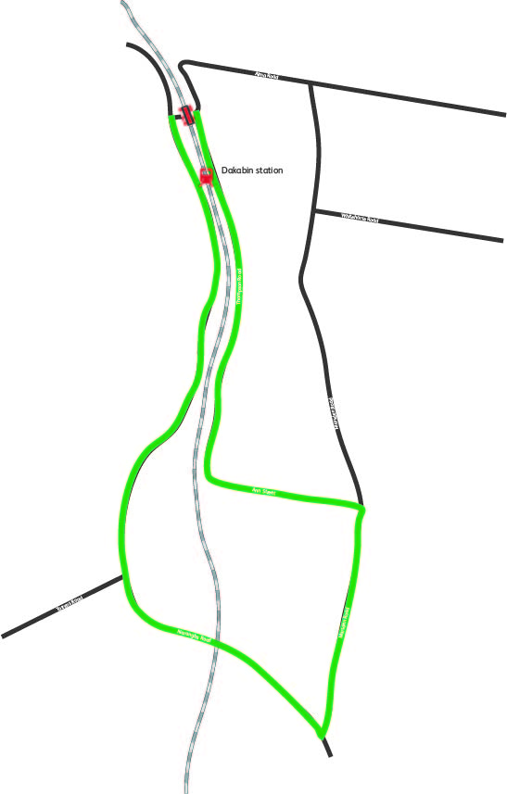

Alma Road

ROAD CLOSURE
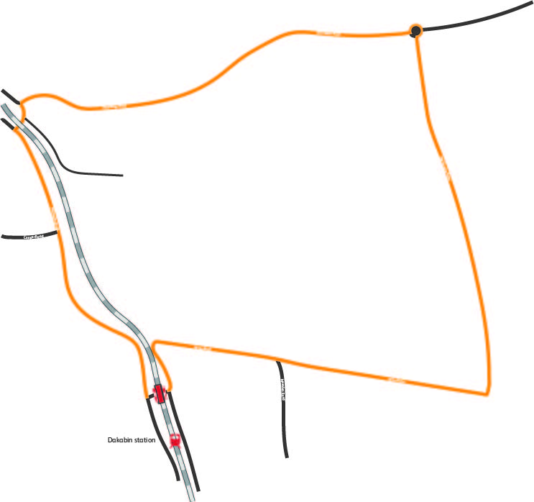

Boundary Road
Thompson Road
Detour A – Southern
ROAD CLOSURE
Narangba Road
Alma Road
Old Gympie Road
Marsden Road
Narangba Road
Narangba Road
Ann Street
Detour B – Northern

