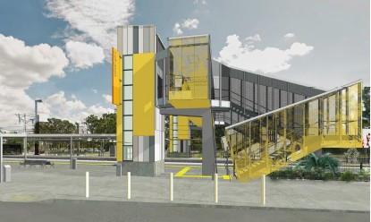
Morayfield station accessibility upgrade

WORKS NOTICE

After hours works noise notice
January/February 2018

As part of the Morayfield station accessibility upgrade’s early works, Queensland Rail will undertake overhead line works on selected nights in late January and February 2018. Due to the nature of these works, they must be undertaken at night when there are no services scheduled. In addition, continuous works will be undertaken during a scheduled weekend track closure on 3 and 4 February.
During these works, access to the work zones within the rail corridor will be via the station carpark and the project compound, established on vacant Queensland Rail land, in Visentin Road. Residents in the local area may experience some noise and lighting associated with construction activities in these locations.
Queensland Rail appreciates your patience and apologises for the inconvenience while these works are undertaken.

Overview of work
Location | Dates and hours of work | Type of work
Morayfield station | - Tuesday 30 January to Friday 2 February 9pm to 4am the next morning (over 4 nights)  - 3am Saturday 3 to 11.59pm Sunday 4 February (continuous works – track closure)  - Tuesday 6 to Friday 9 February 8.30pm to 4.30am the next morning (over 4 nights)  - Monday 12 to Thursday 15 February 8.30pm to 4.30am the next morning (over 4 nights)  - Monday 19 to Friday 23 February 8.30pm to 4.30am the next morning (over 5 nights)  - Monday 26 to Wednesday 28 February 8.30pm to 4.30am the next morning (over 3 nights) | Overhead line works and installation of track crossings and barriers.  This will involve:  - crane operation  - on-track vehicles, heavy machinery and trucks with flashing lights and reversing beepers  Queensland Rail Limited ABN 71 132 181 090  - the use of small tools including hammers and drills  - delivery and movement of equipment and materials  - movement of vehicles around the station precinct  - portable lighting towers.

The Morayfield station accessibility upgrade is part of Queensland Rail’s program to upgrade high priority stations across the South East Queensland network, to ensure that all customers can travel safely and easily.
For further information regarding this work, please contact the project team on 1800 722 203 (free call) or email stationsupgrade@qr.com.au

Queensland Rail is moving towards paperless notifications about noise, works and track closures. You will still see paper notices for a time, as we transition to the new system and you will still receive paper notices if you prefer. Sign up at: queenslandrail.com.au/EmailNotification

