SEQ Rail Stabling Program
Woombye weekend works

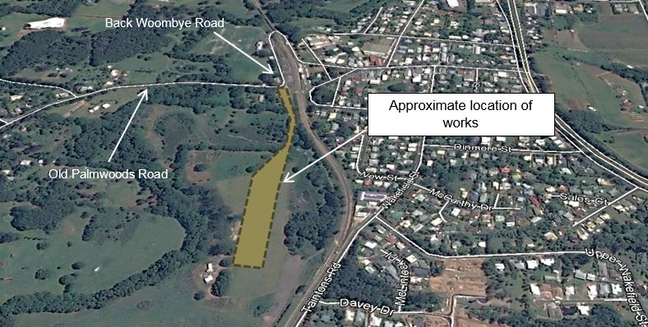

As part of the SEQ Rail Stabling Program, Queensland Rail and CPB Contractors will be undertaking vital construction activities within the rail corridor during the scheduled track closure of the North Coast line on 29 and 30 April 2017.

Works undertaken as part of the scheduled track closure will occur from 5am until 6pm on both Saturday 29 and Sunday 30 April 2017, weather permitting. Some activity is likely to commence around 4am with workers arriving to site and preparing for the works. The scheduled track closure works will include:
- installing signalling infrastructure
- minor track works.

Construction activities will include the use of machinery such as mobile cranes, generators, vacuum excavation trucks, and small power tools such as drills, track welders, saws and hammers.

The project team will endeavour to minimise the impact of works on neighbouring residents as much as possible. This includes:
- toolbox talks with work crews to remind them of out-of-hours work protocols e.g. no unnecessary shouting, whistling, beeping car horns
- using only the required and quietest possible equipment for these works.

We appreciate your patience during the construction period and will continue to update you as work progresses.
Who can I contact?
If you have any questions, or would like to register for more information, please contact the project team on 1800 783 334 (free call) or stabling@qr.com.au
CPB Contractors can be reached on 1800 783 334 (press 1).
Visit queenslandrail.com.au/stabling anytime for more information and updates.

