Road closure
Pine Street, Wynnum
8pm Wednesday 26 to 5am Thursday 27 July 2017

Due to unforeseen circumstances, installation of the protection beam at Pine Street Rail Bridge has been delayed until Wednesday 26 July.
Please be advised that the temporary road closure of Pine Street between Tingal Road and Henry Street will now be in place from 8pm Wednesday 26 to 5am Thursday 27 July.
During this time, traffic management including detour signage will be in place to direct road users and pedestrians around the closure.
Local and pedestrian access will be maintained at the instruction of the traffic controller.
Residents adjacent to the works may experience some noise from the operation of plant and equipment, construction activities and truck movements during these works.
Every effort will be made to carry out these works with minimal disruption.
Queensland Rail apologises for any inconvenience this change of date has caused, and appreciates the local community’s cooperation during these important works.
For traffic management queries, please contact JF Hull on 0437 718 216.
For more information about the Bridge Strike Protection Project contact the project on free call 1800 959 989 or email communityengagement@qr.com.au

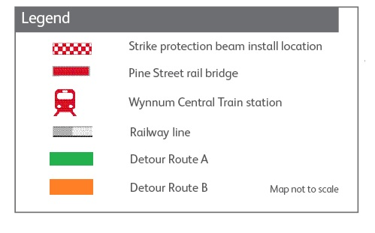
*Please note there are two diversion routes, depending on your direction of travel.

