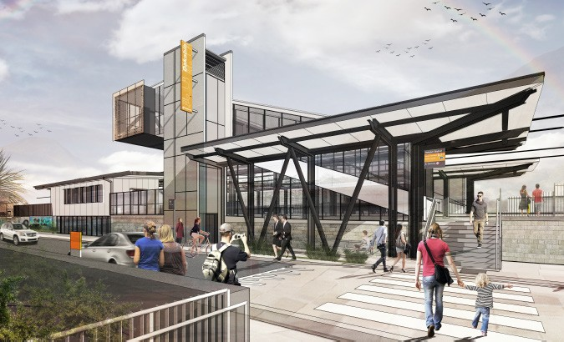Dakabin station accessibility upgrade

PROJECT UPDATE – OCTOBER 2018

The Dakabin station accessibility upgrade is part of Queensland Rail’s $300 million program to upgrade stations across the network, making them accessible for all customers.

Concept designs for the Dakabin station accessibility upgrade are now complete. The upgrade will include:
- a pedestrian footbridge with lift access
- a multi-storey car park with disability and motorcycle spaces
- two new disability parking spaces and a kiss ‘n’
We will continue to refine the designs for the Dakabin station accessibility upgrade. As we move through the design and construction phases, we will keep local residents, customers and community groups well informed of the project’s progress.
For further information:

ride on Narangba Road
- a kiss ‘n’ ride and bus stop on each side of Thompson Road
- a new station building with a public unisex accessible toilet
- 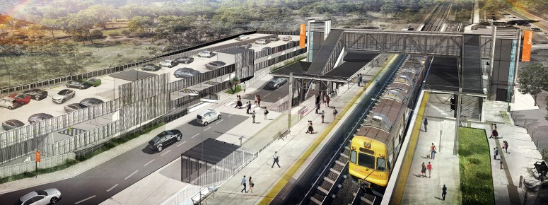a raised section of platform at assisted boarding points
- new platform shelters
- upgraded tactile surface indicators and hearing augmentation loops
- a new 24-space bicycle enclosure on Thompson Road
- new wayfinding and platform signage
- upgraded security cameras and lighting.
Concept designs are available to view on Queensland Rail’s website and at the station.
Phone: Email: Post: Website:
1800 722 203 (free call)

stationsupgrade@qr.com.au
GPO Box 1429, Brisbane, QLD 4000 queenslandrail.com.au

Delivery of Queensland Rail’s $300 million Station Accessibility Upgrade Program will ensure 83% of customers will travel to or from an accessible station.

Nambour | Dinmore | Graceville | Newmarket | Alderley | Strathpine | Morayfield | Boondall
Completed | Completed | Completed | Completed | Completed | Early works | Early works | Early works
Apr 2017 | Jun 2017 | Sep 2017 | Nov 2017 | Nov 2017 | commenced | commenced | commenced
 |  |  |  |  | late 2017 | late 2017 | early 2018

Albion
Design stage
Fairfield
Design stage
Auchenflower
Design stage
Loganlea
Design stage
Cannon Hill
Design stage
Buranda
Design stage
East Ipswich
Design stage
Dakabin
Design stage
Queensland Rail Limited ABN 71 132 181 090 QR2018

