Queensland Rail Limited ABN 71 132 181 090 QR_A3_2017

Eumundi station platform upgrade
May to December 2019
Queensland Rail will upgrade and modernise the platform at Eumundi station to improve facilities for customers. This is part of a $4 million project to upgrade platforms at three Sunshine Coast line stations.
Works will be undertaken in two stages to limit impacts on services and will commence in June for approximately seven months. Early works began in May to prepare for the platform construction.
Geotechnical activities and the construction of a temporary rail crossing will be completed at night to minimise impact for our customers.
Queensland Rail will stage works to ensure customers can continue to access trains and the platform during construction.

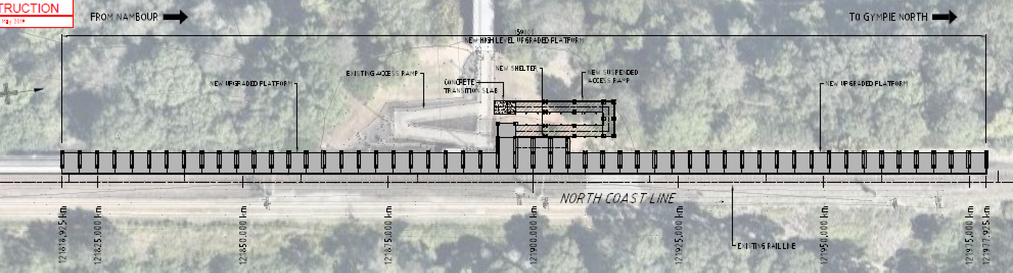

GYMPIE
New access ramp

New waiting shelter with bin
New platform with painted platform markings, upgraded lighting and security cameras
BRISBANE
Please note that the location of the platform has changed since originally advised. It will now be 70m further to the north. This will result in operational benefits and reduces construction time.

For further information, call 13 16 17 or email communityengagement.com.au

