Queensland Rail Limited ABN 71 132 181 090 QR_A3_2017

Temporary carpark closure
From 6am until 6pm on Wednesday 1 and Thursday 2 May 2019
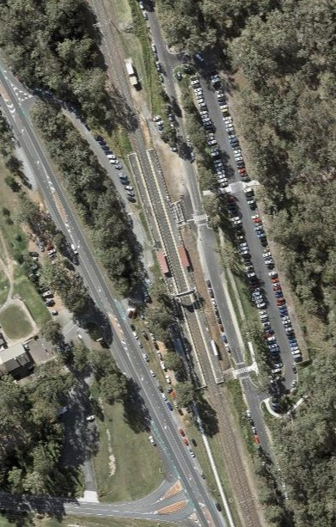Due to preliminary works for the station accessibility project at Dakabin, the western carpark from Narangba Road will be closed between 6am and 6pm on
Wednesday 1 and Thursday 2 May. The carpark will be used to store equipment and materials for platform works. The western station entrance will remain open.
Traffic management will be in place to help direct traffic. The eastern carpark will remain open.
We apologise for any inconvenience and appreciate your patience as we
work to improve your station. Carpark closure Map data ©2019 Google

For more information, please call 13 16 17 (business hours) or email customerfeedback@qr.com.au

