Layard Street

Temporary pedestrian
path closure
From Monday 16 October 2017
The pedestrian access from Layard Street to Goodna station will be closed from Monday 16 October for approximately three weeks to facilitate landscaping works.
Pedestrians can access Goodna station via the path on Layard Street and the connecting path on Rissman Court.
We apologise for any inconvenience as we work to improve your station.

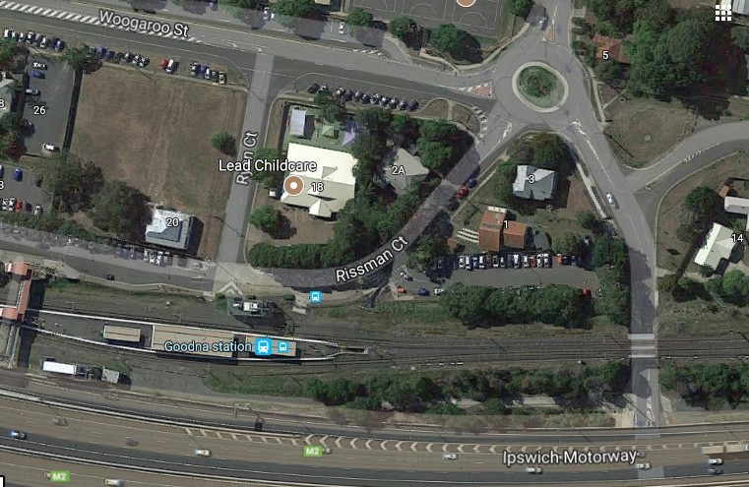Map courtesy of Google Maps
Pedestrian path closed
Alternative access
Queensland Rail Limited ABN 71 132 181 090 QR_A3_2017

If you require assistance with station access call 13 16 17 from 8am to 5pm Monday to Friday or text only 0428 774 636
Visit translink.com.au or call 13 12 30 anytime for more information, updates or assistance out of hours

