Northgate station
Partial carpark closure
13 August 2018 to early 2019

Queensland Rail is committed to improving the safety and security of our network to ensure our customers feel safe on our trains and at our stations.
Due to the construction of a new Queensland Police Service outpost at Northgate station, Queensland Rail will carry out works to reconfigure the carpark and provide additional accessible parking for customers.
This will result in the temporary closure of ten parking spaces on the station side of Ridge Street for machinery and materials storage. Seven of these spaces will be reinstated upon completion, with the outpost building taking up an area which includes three parking spaces.
We apologise for any inconvenience and appreciate your patience as we work to improve the safety of your network.
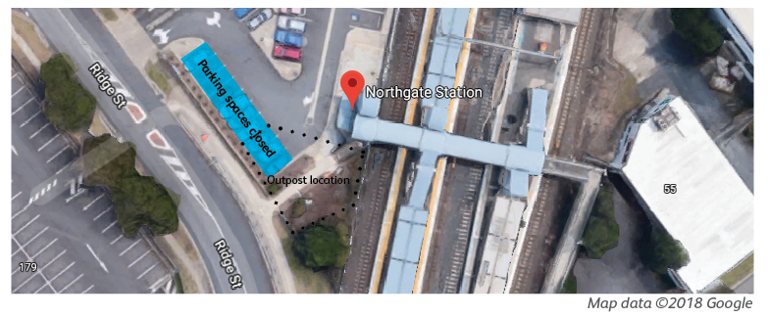
Northgate station map with closed carpark spaces highlighted. Map data © 2018 Google

For more information, please see station staff, call 13 16 17 (business hours) or email customerfeedback@qr.com.au

