Partial carpark closures

Monday 7 until Wednesday 16 January 2019
Saturday 19 until Saturday 26 January 2019
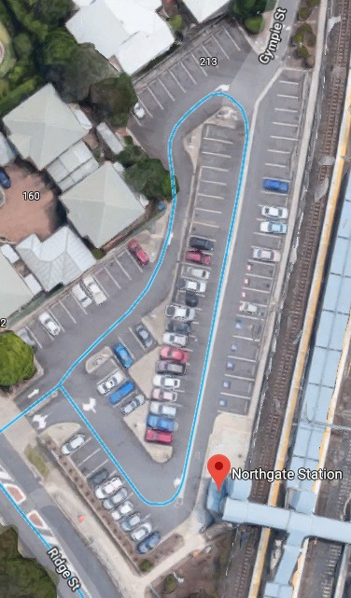Due to the construction of the new QPS outpost and
Stage 1 closure
reconfiguration of the carpark, car spaces will be closed, during two stages.
From Monday 7 until Wednesday 16 January, the carparks indicated in Stage 1 (red) will be closed.
From Saturday 19 until Saturday 26 January, the carparks indicated in Stage 2 (blue) will be closed.
Map data ©2018 Google
As work progresses, we will make as many car spaces available as possible.

Stage 1 - car park closed
Stage 2 - car park closed
Site office

We apologise for any inconvenience and appreciate your patience as we work to improve your network.
Queensland Rail Limited ABN 71 132 181 090 QR_A3_2017
For more information, please see station staff, call 13 16 17 (business hours) or email customerfeedback@qr.com.au

