Changed station access
Ridge Street
13 August 2018 to early 2019

Due to the construction of a new Queensland Police Service outpost at Northgate station, Queensland Rail will temporarily change access to the station from Ridge Street. Please refer to the map below.
Please be aware of your surroundings and proceed safely at all times.
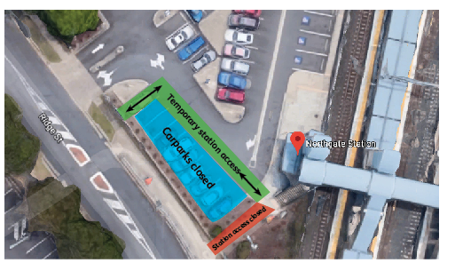
Northgate station map with closed carpark spaces and temporary station access highlighted. Map data © 2018 Google

We apologise for any inconvenience and appreciate your patience as we work to improve the safety of your network.
For more information, please see station staff, call 13 16 17 (business hours) or email customerfeedback@qr.com.au

