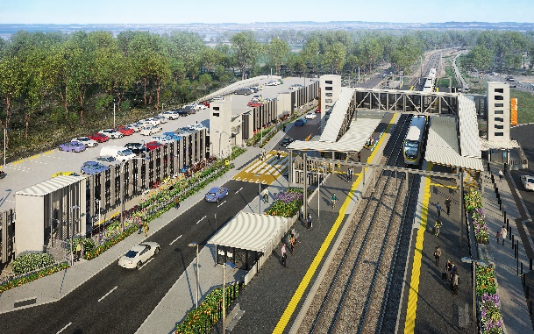
Dakabin station accessibility upgrade

WORKS NOTICE

After hours works including weekend station closure
11.30pm Friday 4 to 5am Monday 7 December 2020
As part of the Dakabin station accessibility upgrade, night and weekend works will be undertaken from 11.30pm on Friday 4 to 5am Monday 7 December.
Rail services will not stop at Dakabin on Saturday 5 and Sunday 6 December. All Caboolture and Sunshine Coast line services will continue as scheduled.
A free shuttle will operate every 30 minutes from Narangba Road to transport customers to and from Petrie station, providing a connection to scheduled rail services (north- and southbound). Please allow at least an additional 30 minutes for travel or consider using an alternative station, if convenient.
This weekend closure will allow uninterrupted access for platform works without disrupting services on the Caboolture and Sunshine Coast line. These intensive works are a critical step towards project completion.
During these works, safe pedestrian access through the precinct will be provided and the station’s footbridge will remain open for cross-corridor pedestrian traffic.
Residents near the station may experience some noise associated with construction activity and truck movements. Mobile lighting towers will be used during night works.
Queensland Rail Limited ABN 71 132 181 090

Scheduled works
Location | Dates and hours of work | Type of work
Dakabin station precinct | After hours works:  - 11.30pm Friday 4 to  5am Monday 7 December  (continuous works)  Station closed with no services stopping on Saturday 5 and Sunday 6 December. | Station upgrade and platform works involving:  - paving and painting  - heavy machinery and trucks with flashing lights and reversing beepers  - hand-held tools and powered equipment  - movement of people and vehicles around the station precinct  - portable lighting in use at night.

The Dakabin station accessibility upgrade is part of the State Government’s investment to upgrade stations across the South East Queensland network, making them accessible for all customers. For more information, please contact the project’s community team on free call 1800 722 203 or email stationsupgrade@qr.com.au

