Energex works – road reserve near Dakabin station
Sunday 30 June to Wednesday 3 July 2019
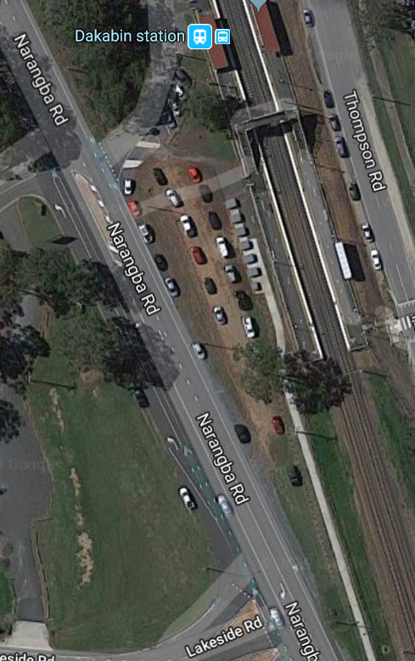
Due to Energex works to upgrade the power supply at Dakabin station, a section of the Narangba Road reserve (see map) will be a dedicated construction zone.
Access to the area will be unavailable from Sunday 30 June to Wednesday 3 July.
We apologise for any inconvenience and appreciate your patience as we work to improve your station.
Energex work zone
Map data ©2019 Google
Queensland Rail Limited ABN 71 132 181 090 QR_A3_2017

For more information, please contact 1800 722 203 (free call) or email stationsupgrade@qr.com.au

