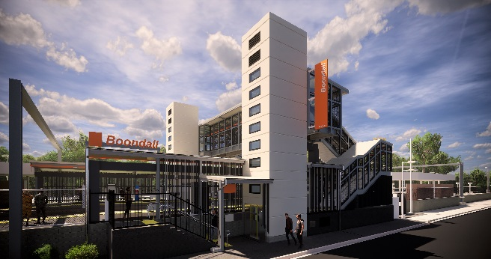
Boondall station accessibility upgrade

WORKS NOTICE

Night works – platform activities
Monday 17 to Thursday 20 February 2020

As part of the Boondall station accessibility upgrade, platform works will be undertaken for up to four nights from Monday 17 to Thursday 20 February, from 6.30pm to 6.30am the next day (weather and construction conditions permitting). Works will only be scheduled for Thursday 20 February if required.
For safety, these works can only be undertaken after hours, when there is reduced rail traffic and fewer customers around the station precinct.
Residents near the station may experience some noise associated with construction activity, operation of an asphalting machine, high-pressure water cleaning and truck movements. Mobile lighting towers will be used during night works.
Every effort will be made to minimise disruption and we apologise for any inconvenience as we work to improve your station.
Scheduled night work
Queensland Rail Limited ABN 71 132 181 090
Location | Dates and hours of work | Type of work
Boondall station  Footbridge (open) | 6.30pm to 6.30am the next day on:  - Monday 17 February  - Tuesday 18 February  - Wednesday 19 February  - Thursday 20 February  (up to 4 nights, Thursday night only if required) | Station upgrade and platform works involving:  - asphalting platform surfaces  - heavy machinery and trucks with flashing lights and reversing beepers  - hand-held tools and powered equipment  - high-pressure water cleaning  - painting  - movement of personnel and vehicles around the station precinct  - portable lighting towers at night.
In addition to the scheduled works outlined above, on Thursday night 6 February, the Gateway Upgrade North project is carrying out some rectification works (line marking) in the station carpark.
The Boondall station accessibility upgrade is part of the State Government’s $357 million investment to upgrade stations across the South East Queensland network, making them accessible for all customers.
For more information about the Boondall station accessibility upgrade, please contact the project’s community team during business hours on 1800 722 203 (free call) or email stationsupgrade@qr.com.au

We are moving towards paperless notifications about noise and works. You will still see paper notices as we transition to the new system. Sign up at queenslandrail.com.au/EmailNotification or contact us if you prefer to receive paper copies.

