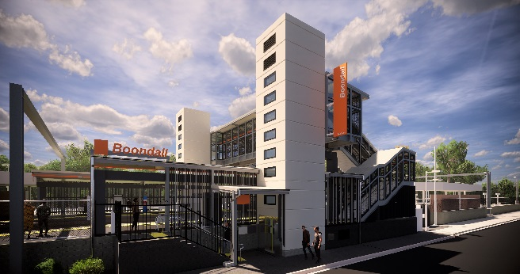
Boondall station accessibility upgrade

WORKS NOTICE

Night works – platform activities
November 2019

As part of the Boondall station accessibility upgrade, works will be undertaken over five nights from Sunday 10 to Thursday 14 November, from 8pm to 6am the next day (weather and construction conditions permitting).
For safety, these works can only be undertaken after hours, when there is no rail traffic and no customers on the platforms.
Residents near the station may experience some noise associated with construction activity and truck movements. Mobile lighting towers will be used during night works.
Every effort will be made to minimise disruption and we apologise for any inconvenience as we work to improve your station.

Scheduled night work
Queensland Rail Limited ABN 71 132 181 090
Location | Dates and hours of work | Type of work
Boondall station  Footbridge (open) | 8pm to 6am the next day on:  - Sunday 10 November  - Monday 11 November  - Tuesday 12 November  - Wednesday 13 November  - Thursday 14 November  (over 5 nights) | Station upgrade works involving:  - asphalting platform surfaces and ramps  - heavy machinery and trucks with flashing lights and reversing beepers  - hand-held tools and powered equipment  - movement of personnel and vehicles around the station precinct  - portable lighting towers at night.

The Boondall station accessibility upgrade is part of the State Government’s $357 million program to upgrade stations across the South East Queensland network, making them accessible for all customers.
For more information about the Boondall station accessibility upgrade, please contact the project’s community team during business hours on 1800 722 203 (free call) or email stationsupgrade@qr.com.au

We are moving towards paperless notifications about noise and works. You will still see paper notices as we transition to the new system. Sign up at queenslandrail.com.au/EmailNotification or contact us if you prefer to receive paper copies.

