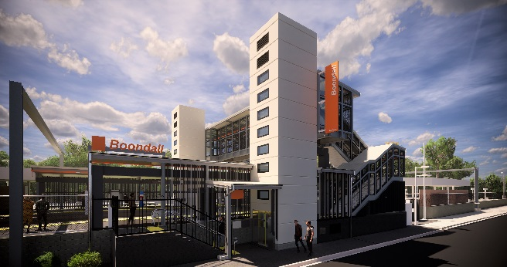
Boondall station accessibility upgrade

WORKS NOTICE

Night works – concrete removal and platform activities
Tuesday 15 October 2019

As part of the Boondall station accessibility upgrade, night works will be undertaken at the station on Tuesday 15 October, from 11pm to 6am the next day (weather and construction conditions permitting).
For safety, these works can only be undertaken after hours, when there is no rail traffic and no customers on the platforms.
A jackhammer will be used to remove a concrete section of platform. Residents near the station may experience some noise associated with construction activity and truck movements. Mobile lighting towers will be used during night works.
Note: In the event of adverse weather or construction conditions, works will continue the following night on Wednesday 16 October.
Every effort will be made to minimise disruption and we apologise for any inconvenience as we work to improve your station.
Scheduled night work
Queensland Rail Limited ABN 71 132 181 090
Location | Dates and hours of work | Type of work
Boondall station  Footbridge (open) | 11pm to 6am the next day on:  - Tuesday 15 October  (overnight)  - Wednesday 16 October  (only if required) | Station upgrade works involving:  - concrete removal including the use of a jackhammer  - platform works including excavation  - heavy machinery and trucks with flashing lights and reversing beepers  - hand-held tools and powered equipment  - movement of personnel and vehicles around the station precinct  - portable lighting towers at night.
Queensland Rail’s Boondall station accessibility upgrade is part of the program to upgrade stations across the South East Queensland network, making them accessible for all customers.
For more information about the accessibility upgrade, please contact the project’s community team during business hours on 1800 722 203 (free call) or email stationsupgrade@qr.com.au

We are moving towards paperless notifications about noise and works. You will still see paper notices as we transition to the new system. Sign up at queenslandrail.com.au/EmailNotification or contact us if you prefer to receive paper copies.

