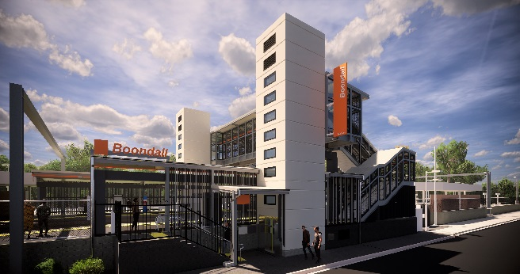
Boondall station accessibility upgrade

WORKS NOTICE

Night and weekend works – Boondall station closure

11.30pm Friday 6 to 4am Monday 9 September 2019

As part of the Boondall station accessibility upgrade, continuous works will be undertaken at the station from 11.30pm Friday 6 until 4am Monday 9 September.
On this weekend the station will be closed with no rail services stopping at Boondall. All other Shorncliffe line services will continue as scheduled.
A free shuttle will operate every 30 minutes to transport customers to and from North Boondall station, providing a connection to scheduled rail services. Please allow an additional 30 minutes for travel, alternatively you may consider using North Boondall or Nudgee stations if convenient.
A further closure is planned for the weekend of 19-20 October, which will allow uninterrupted access to install the final platform surface without disrupting services on the Shorncliffe line. These intensive works are a critical step towards project completion.
Please observe the changed conditions and take care around the work zones.
For the safety of the public, there will be no access to the station, however the existing footbridge will remain open to pedestrians crossing the rail corridor. Access to private properties will be maintained at all times.

Scheduled night/weekend work
Location | Dates and hours of work | Type of work
Boondall station  Platforms and facilities (closed)  Footbridge (open) | 11.30pm Friday 6 to  4am Monday 9 September  (continuous, around-the-clock works) | Station upgrade works involving:  - platform works including excavation  - heavy machinery and trucks with flashing lights and reversing beepers  - hand-held tools and powered equipment  - movement of people and vehicles around the station precinct  - portable lighting used at night.

Every effort will be made to minimise disruption and we apologise for any inconvenience as we work to improve your station.
The Boondall station accessibility upgrade is part of the program to upgrade stations across the South East Queensland network, making them accessible for all customers.
For more information about the accessibility upgrade, please contact the project’s community team during business hours on 1800 722 203 (free call) or email stationsupgrade@qr.com.au

We are moving towards paperless notifications about noise and works. You will still see paper notices as we transition to the new system. Sign up at queenslandrail.com.au/EmailNotification or contact us if you prefer to receive paper copies.

