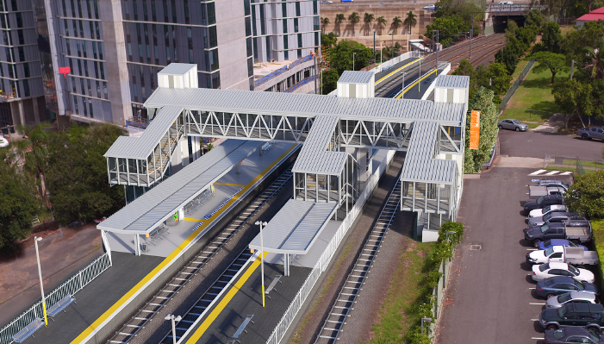
Buranda station accessibility upgrade

WORKS NOTICE

Night works – overhead line infrastructure
Tuesday 10 and Wednesday 11 September 2019

In preparation for the Buranda station accessibility upgrade, overhead line infrastructure works will be undertaken at night on Tuesday 10 and Wednesday 11 September 2019, from 6pm until 6am the next day (weather and construction conditions permitting). These night works are a continuation of preliminary works previously notified. For the safety of workers and the public, these works have been scheduled after hours when there is no rail traffic.
Local residents may experience some noise associated with construction activity and truck movements in the vicinity of Arne, Gillingham and Martin Streets. Mobile lighting towers will be used during night works. Every effort will be made to minimise disruption and we apologise for any inconvenience as we undertake this concentrated period of early works.
Following these foundation works, installation of overhead infrastructure will be undertaken during a scheduled track closure in November. Nearby residents will be notified closer to these activities.

Scheduled night work
Queensland Rail Limited ABN 71 132 181 090
Location | Dates and hours of work | Type of work
Buranda station  Arne, Gillingham and Martin Streets, Woolloongabba  Adjacent rail corridor (rail property and access gates) | 6pm to 6am the next day on:  - Tuesday 10 September  - Wednesday 11 September  (over 2 nights) | Overhead infrastructure works involving:  - excavation and concreting works for the installation of overhead foundations and an on-track vehicle pad  - operation of cranes, trucks and machinery with flashing lights and reversing beepers  - movement of personnel and vehicles around the station precinct and rail corridor  - hand-held tools and powered equipment  - portable lighting towers at night.
Queensland Rail’s Buranda station accessibility upgrade is part of the program to upgrade stations across the South East Queensland network, making them accessible for all customers.
For more information about the accessibility upgrade, please contact the project’s community team during business hours on 1800 722 203 (free call) or email stationsupgrade@qr.com.au

We are moving towards paperless notifications about noise and works. You will still see paper notices as we transition to the new system. Sign up at queenslandrail.com.au/EmailNotification or contact us if you prefer to receive paper copies.

