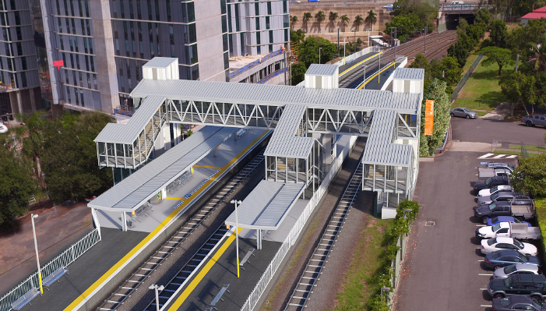
Buranda station accessibility upgrade

WORKS NOTICE

Night works – overhead line infrastructure
7 September 2019

In preparation for the Buranda station accessibility upgrade, overhead line infrastructure works will be undertaken at night on Saturday 7 September, from 6pm until 6am the next day (weather and construction conditions permitting).
For the safety of workers and the public, these works have been scheduled after hours when there is no rail traffic.
Residents near the station may experience some noise associated with construction activity and truck movements. The Queensland Rail property at 13 Arne Street will be used for a laydown area and may be used by project vehicles for access to the rail corridor and its infrastructure. Mobile lighting towers will be used during night works.
Every effort will be made to minimise disruption and we apologise for any inconvenience as we undertake this concentrated period of early works.

Scheduled night work
Queensland Rail Limited ABN 71 132 181 090
Location | Dates and hours of work | Type of work
Buranda station  Arne Street, Woolloongabba  Adjacent rail corridor (rail property and access gates) | 6pm to 6am the next day on:  - Saturday 7 September  (overnight works) | Overhead infrastructure works involving:  - excavation and concreting works for the installation of overhead foundations  - operation of cranes, trucks and machinery with flashing lights and reversing beepers  - movement of personnel and vehicles around the station precinct and rail corridor  - hand-held tools and powered equipment  - portable lighting towers at night.
Queensland Rail’s Buranda station accessibility upgrade is part of the program to upgrade stations across the South East Queensland network, making them accessible for all customers.
For more information about the accessibility upgrade, please contact the project’s community team during business hours on 1800 722 203 (free call) or email stationsupgrade@qr.com.au

We are moving towards paperless notifications about noise and works. You will still see paper notices as we transition to the new system. Sign up at queenslandrail.com.au/EmailNotification or contact us if you prefer to receive paper copies.

