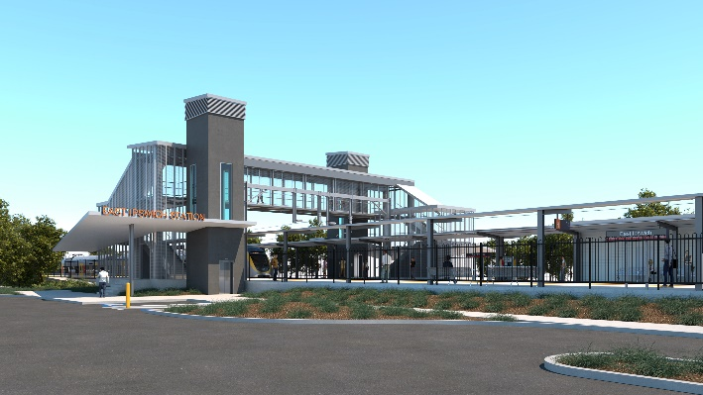
East Ipswich station accessibility upgrade

WORKS NOTICE

Additional lighting commissioning – night works

Thursday 14 October 2021

Additional lighting commissioning activities, including lux testing on the station platforms, will be undertaken overnight on Thursday 14 October, as part of the East Ipswich station accessibility upgrade.
Nearby residents will notice increased lighting overnight and this additional testing is a necessary part of commissioning the lighting design. These additional commissioning activities are not expected to create excessive noise and the project team will make every effort to minimise disturbance wherever possible.
We apologise for any inconvenience as we undertake these additional night activities.
Upon commissioning of the new lighting system, the station’s lights will operate nightly as they would under normal operational conditions.
Overview of works
Queensland Rail Limited ABN 71 132 181 090
Location | Dates and hours of work | Type of work
East Ipswich station precinct – platforms  Adjacent footpaths:  - Merton Street  - Coronation Street  Work zones and site offices | Thursday 14 October, 6pm to 6am the next day  (overnight works) | Station platform lighting commissioning activities:  - station lighting system operating overnight  - lux testing (platforms)  - electrical and switchboard activities  - use of hand-held equipment and powered tools  - movement of personnel and vehicles around the station precinct and rail corridor  - use of light towers to light work zones at night.

The East Ipswich station accessibility upgrade is part of the State Government’s ongoing investment of more than $500 million to upgrade stations across the South East Queensland network, making them accessible for all customers.
For more information, please contact the project’s community team on free call 1800 722 203 or email stationsupgrade@qr.com.au

Sign up for electronic notifications at queenslandrail.com.au/EmailNotification

