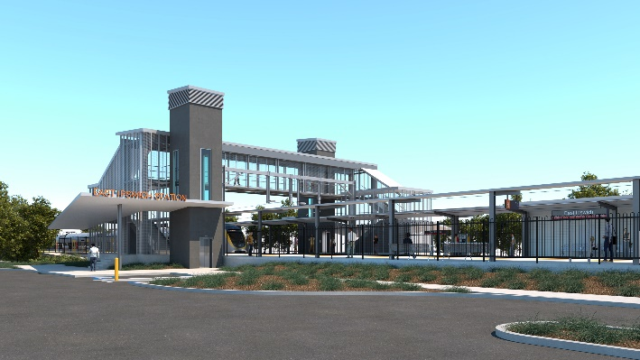
East Ipswich station accessibility upgrade

WORKS NOTICE

Bennett Street carpark and station entrance closure

From Monday 20 December 2021 to mid-2022

To enable platform demolition and construction of a new pedestrian path, the Bennett Street carpark and station entrance will be closed from Monday 20 December 2021 until approximately mid-2022.
During this time, access to the station on the southern side of the rail line will be via the new station entrance on Coronation Street (corner of Gibbon Street).
Alternative customer parking will be available in the Merton Street and Coronation Street station carparks.
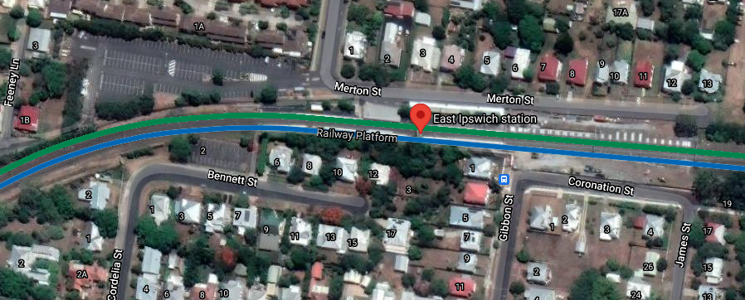
We apologise for any inconvenience and appreciate your patience as we undertake these important works.
Map data © Google, 2021

CARPARK

CARPARK

Platforms closed – no access to station
Carpark closed 20 Dec to mid-2022
New station entrances

The East Ipswich station accessibility upgrade is part of the State Government’s ongoing investment of more than $500 million to upgrade stations across the South East Queensland network, making them accessible for all customers.
For more information, please contact the project’s community team on free call 1800 722 203 or email stationsupgrade@qr.com.au

Sign up for electronic notifications at queenslandrail.com.au/EmailNotification

