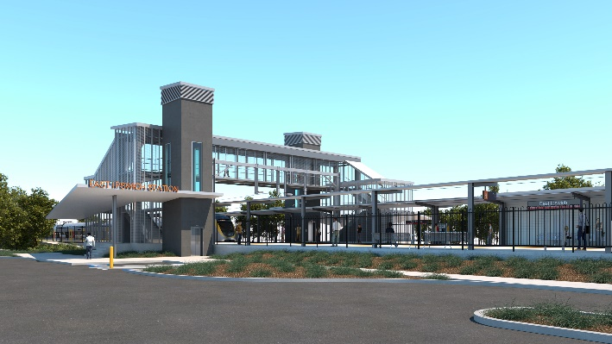
East Ipswich station accessibility upgrade

WORKS NOTICE

Weekend and night works

Saturday 20 and Sunday 21 August 2022

Queensland Rail will undertake finishing works associated with the East Ipswich station accessibility upgrade during the planned weekend track closure on Saturday 20 and Sunday 21 August.
Activities will include around-the-clock works from 6am Saturday 20 until 11pm Sunday 21 August (weather and construction conditions permitting).
Platform works involve paving on both platforms and the operation of a crane for approximately four hours on Saturday morning. Generators will be in operation over the weekend.
For safety, these works have been planned during a scheduled closure of the Ipswich/Rosewood line when buses will replace trains.
The new station footbridge will be open for cross-corridor pedestrian access.
Every effort will be made to minimise disturbance wherever possible. We apologise for any inconvenience and appreciate your patience as we undertake these important works.
Overview of works
Queensland Rail Limited ABN 71 132 181 090
Location | Dates and hours of work | Type of work
East Ipswich station precinct  Coronation Street station carpark (closed for crane lift and weekend works)  Bennett Street carpark (currently closed) | Weekend works during track closure:  6am Saturday 20 to 11pm Sunday 21 August  (continuous, around-the-clock works) | Platform works involving:  - paving (platforms 1 and 2)  - operation of a crane (Coronation Street)  - use of hand-held equipment and powered tools  - operation of generators  - operation of heavy equipment and trucks with flashing lights and reversing beepers  - movement of personnel and vehicles around the station precinct and rail corridor  - traffic management – Coronation Street  - use of lighting towers at night.

The East Ipswich station accessibility upgrade was officially opened in January 2022 and is part of the State Government’s ongoing investment of more than $500 million to upgrade stations across the South East Queensland network, making them accessible for all customers.
For more information, please contact the project’s community team on free call 1800 722 203 or email stationsupgrade@qr.com.au

Sign up for electronic notifications at queenslandrail.com.au/EmailNotification

