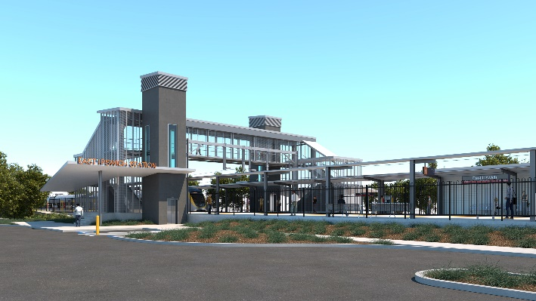
East Ipswich station accessibility upgrade

WORKS NOTICE

Weekend and night works

May 2022

As part of the demolition phase of the East Ipswich station accessibility upgrade, Queensland Rail will undertake weekend works (including around-the-clock activities) from 6am Saturday 7 until 2am Monday 9 May 2022 (weather and construction conditions permitting).
For safety, these works have been planned during a scheduled closure of the Ipswich/Rosewood line when buses will replace trains. The new station footbridge will be open for cross-corridor pedestrian access.
Works include demolition of the station’s old platforms involving saw-cutting concrete and excavation with on-track vehicles and heavy equipment. Some activities are scheduled to conclude on Sunday, with others extending overnight. Noisy (on-track) activities are expected to conclude by approximately 10pm Sunday night.
Every effort will be made to minimise disturbance wherever possible. We apologise for any inconvenience and appreciate your patience as we undertake these important works.
Overview of works
Queensland Rail Limited ABN 71 132 181 090
Location | Dates and hours of work | Type of work
East Ipswich station precinct and rail corridor  Main station carpark, Merton Street (closed)  Bennett Street carpark (closed)  Rail corridor access gates:  - Merton Street  - Coronation Street | Weekend works during track closure:  6am Saturday 7 to 2am Monday 9 May  (continuous, around-the-clock works) | Station upgrade demolition works involving:  - operation of on-track vehicles (excavator)  - operation of concrete saw-cutters, jackhammers and rock-breaking equipment  - operation of a generator  - drainage works  - paving – platform 1  - use of hand-held equipment and powered tools  - operation of heavy equipment and trucks with flashing lights and reversing beepers  - movement of personnel and vehicles around the station precinct and rail corridor  - traffic management – Merton Street  - use of lighting towers at night.

The East Ipswich station accessibility upgrade is part of the State Government’s ongoing investment of more than $500 million to upgrade stations across the South East Queensland network, making them accessible for all customers.
For more information, please contact the project’s community team on free call 1800 722 203 or email stationsupgrade@qr.com.au

Sign up for electronic notifications at queenslandrail.com.au/EmailNotification

