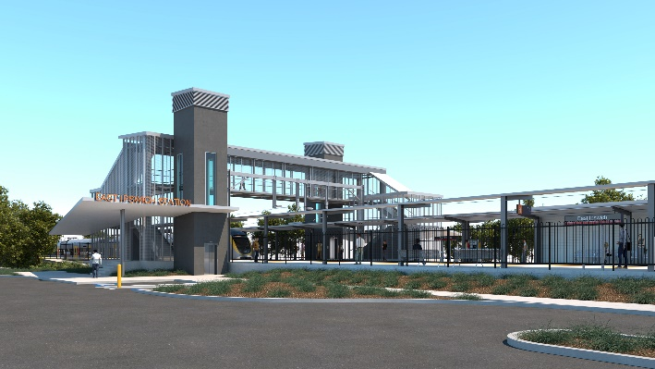
East Ipswich station accessibility upgrade

WORKS NOTICE

Weekend and night works

October 2021

As part of the East Ipswich station accessibility upgrade, Queensland Rail will undertake continuous weekend works from 8pm Friday 22 until 5am Monday 25 October 2021 (weather and construction conditions permitting).
Works include the removal of the station’s old timber footbridge and preparatory works for the demolition of the current station building and platforms.
These works have been planned during a scheduled closure of the Ipswich/Rosewood line when buses will replace trains. A free taxi shuttle between Merton Street and Coronation Street will provide pedestrian access across the rail corridor during works.
Following these weekend works, overhead line infrastructure works will be undertaken overnight on Monday 25 October, 8pm until 6am the next day.
Every effort will be made to minimise disturbance wherever possible. We apologise for any inconvenience and appreciate your patience as we undertake these important works.
Overview of works
Queensland Rail Limited ABN 71 132 181 090
Location | Dates and hours of work | Type of work
East Ipswich station precinct and rail corridor  Main station carpark (closed)  Rail corridor access gates:  - Merton Street  - Coronation Street | Weekend works during track closure:  8pm Friday 22 to 5am Monday 25 October  (continuous, around-the-clock works)  Night works:  8pm to 6am the next day on:  - Monday 25 October  (overnight works) | Station upgrade works involving:  - operation of large cranes (bridge removal)  - operation of jackhammers and rock-breaking equipment  - use of hand-held equipment and powered tools  - operation of heavy equipment and trucks with flashing lights and reversing beepers  - movement of personnel and vehicles around the station precinct and rail corridor  - traffic management – Merton Street  - use of lighting towers at night.

The East Ipswich station accessibility upgrade is part of the State Government’s ongoing investment of more than $500 million to upgrade stations across the South East Queensland network, making them accessible for all customers.
For more information, please contact the project’s community team on free call 1800 722 203 or email stationsupgrade@qr.com.au

Sign up for electronic notifications at queenslandrail.com.au/EmailNotification

