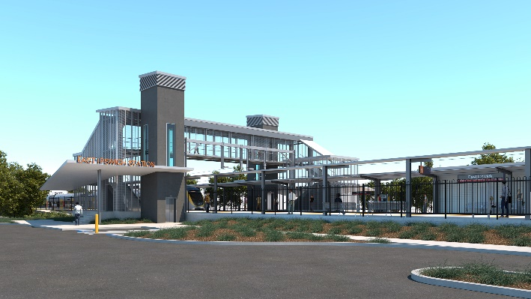
East Ipswich station accessibility upgrade

WORKS NOTICE

After hours works

Sunday 19 December 2021

In preparation for commencing operations of the new East Ipswich station, Queensland Rail will undertake linemarking and painting activities on the new platforms on Sunday 19 December 2021.
Works will be undertaken during the day shift and then overnight (weather and construction conditions permitting).
Due to the nature and location of these activities, works can only be undertaken out of hours when rail traffic is reduced.
While these activities are not expected to be noisy, every effort will be made to minimise disturbance wherever possible.
We apologise for any inconvenience and appreciate your patience as we undertake these important works.

Overview of works
Queensland Rail Limited ABN 71 132 181 090
Location | Dates and hours of work | Type of work
East Ipswich station precinct – platforms | Sunday 19 December  Day shift: 6.30am to 6.30pm  Overnight: 6.30pm to 5am the next day  (after hours and overnight works) | Platform activities involving:  - linemarking and painting  - use of hand-held equipment and powered tools  - movement of personnel and vehicles around the station precinct and rail corridor  - use of lighting towers/station lighting at night.

The East Ipswich station accessibility upgrade is part of the State Government’s ongoing investment of more than $500 million to upgrade stations across the South East Queensland network, making them accessible for all customers.
For more information, please contact the project’s community team on free call 1800 722 203 or email stationsupgrade@qr.com.au

Sign up for electronic notifications at queenslandrail.com.au/EmailNotification

