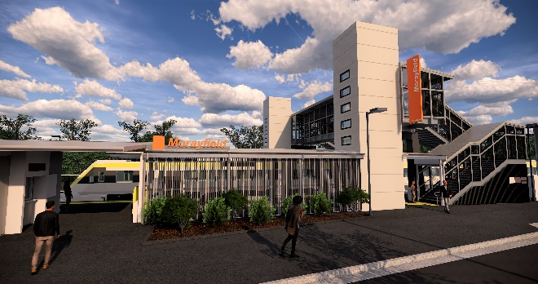
Morayfield station accessibility upgrade

WORKS NOTICE

Night and weekend works – Morayfield station closure

11.30pm Friday 25 to 4am Monday 28 October 2019

As part of the Morayfield station accessibility upgrade, continuous works will be undertaken at the station from 11.30pm Friday 25 until 4am Monday 28 October.
On this weekend the station will be closed with no rail services stopping at Morayfield. All Caboolture and Sunshine Coast line services will continue as scheduled.
A free shuttle bus will operate every 15 minutes to transport customers to and from Caboolture station, providing a connection to scheduled rail services. Please allow at least an additional 30 minutes for travel, alternatively you may consider using Caboolture or Burpengary stations if convenient.
This weekend closure will allow uninterrupted access to install the final platform surface without disrupting services on the Caboolture and Sunshine Coast line. These intensive works are a critical step towards project completion.
Residents near the station may experience some noise associated with construction activity and truck movements. Mobile lighting towers will be used during night works.
For the safety of the public, there will be no access to the station, footbridge or carparks. Please observe the changed conditions and take care around the work zones. Access to private properties will be maintained at all times.

Scheduled night/weekend work
Location | Dates and hours of work | Type of work
Morayfield station  Platforms and facilities (closed)  Footbridge (closed) | 11.30pm Friday 25 to  4am Monday 28 October  (continuous, around-the-clock works) | Station upgrade works involving:  - platform paving works including excavation  - heavy machinery and trucks with flashing lights and reversing beepers  - hand-held tools and powered equipment  - movement of people and vehicles around the station precinct  - portable lighting in use at night.

Every effort will be made to minimise disruption and we apologise for any inconvenience as we work to improve your station.
The Morayfield station accessibility upgrade is part of the Ste Government’s $357 million program to upgrade stations across the South East Queensland network, making them accessible for all customers.
For more information about the accessibility upgrade, please contact the project’s community team on free call 1800 722 203 or email stationsupgrade@qr.com.au

We are moving towards paperless notifications about noise and works. You will still see paper notices as we transition to the new system. Sign up at queenslandrail.com.au/EmailNotification or contact us if you prefer to receive paper copies.

