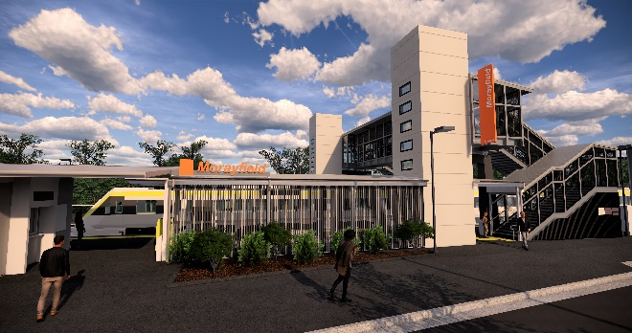
Morayfield station accessibility upgrade

WORKS NOTICE

Night and weekend works – timber footbridge removal
7pm Saturday 2 to 9am Sunday 3 November 2019

As part of the Morayfield station accessibility upgrade, the station’s original timber footbridge will be removed overnight from 7pm Saturday 2 to 9am Sunday 3 November 2019.
These works are being undertaken after hours, when there is no rail traffic and the overhead power is switched off.
Residents near the station may experience some noise associated with construction activity and truck movements. Mobile lighting towers will be used during night works. The concrete staircase bases will be broken up on Sunday morning using rock-breaking equipment.
For the safety of the public, a section of the western carpark will be closed. Access to available parking at the rear of the western carpark will be via the Caboolture Sports Club driveway and gate.

Scheduled night/weekend work
Queensland Rail Limited ABN 71 132 181 090
Location | Dates and hours of work | Type of work
Morayfield station and carpark  Footbridge (closed) | 7pm Saturday 2 to 9am Sunday 3 November  (overnight) | Timber footbridge removal involving:  - large crane operation  - heavy machinery (including rock-breaking equipment) and trucks with flashing lights and reversing beepers  - hand-held tools and powered equipment (including saws)  - movement of personnel and vehicles around the station precinct  - portable lighting towers at night.
Every effort will be made to minimise disruption and we apologise for any inconvenience as we work to improve your station.
The Morayfield station accessibility upgrade is part of the State Government’s $357 million program to upgrade stations across the South East Queensland network, making them accessible for all customers.
For more information about the accessibility upgrade, please contact the project’s community team on free call 1800 722 203 or email stationsupgrade@qr.com.au

We are moving towards paperless notifications about noise and works. You will still see paper notices as we transition to the new system. Sign up at queenslandrail.com.au/EmailNotification or contact us if you prefer to receive paper copies.

