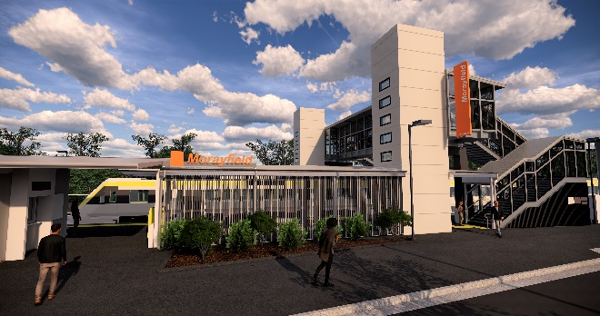
Morayfield station accessibility upgrade

WORKS NOTICE

Night and weekend works – scheduled track closure
11.30pm Friday 23 to 4am Monday 26 August 2019

As part of the Morayfield station accessibility upgrade, continuous works will be undertaken at the station from 11.30pm Friday 23 to 4am Monday 26 August 2019.
These works are being undertaken during a scheduled track closure, when there is no rail traffic and the overhead power is switched off. During the weekend’s track closure, rail replacement buses will operate – refer to the directional signage at the station for the bus stop location.
Residents near the station may experience some noise associated with construction activity and truck movements. Mobile lighting towers will be used during night works.
For the safety of the public during the station and track closure, there will be no public pedestrian access through the station precinct, including carparks, and the footbridge will be closed.
Queensland Rail Limited ABN 71 132 181 090

Scheduled night/weekend work
Location | Dates and hours of work | Type of work
Morayfield station  Carparks closed | 11.30pm Friday 23 to 4am Monday 26 August  (continuous, around-the-clock works) | Station upgrade works involving:  - platform raising and paving  - heavy machinery and trucks with flashing lights and reversing beepers  - hand-held tools and powered equipment  - movement of personnel and vehicles around the station precinct  - portable lighting towers at night.
Every effort will be made to minimise disruption and we apologise for any inconvenience as we work to improve your station.
Queensland Rail’s Morayfield station accessibility upgrade is part of the program to upgrade stations across the South East Queensland network, making them accessible for all customers.
For more information about the accessibility upgrade, please contact the project’s community team on free call 1800 722 203 or email stationsupgrade@qr.com.au

We are moving towards paperless notifications about noise and works. You will still see paper notices as we transition to the new system. Sign up at queenslandrail.com.au/EmailNotification or contact us if you prefer to receive paper copies.

