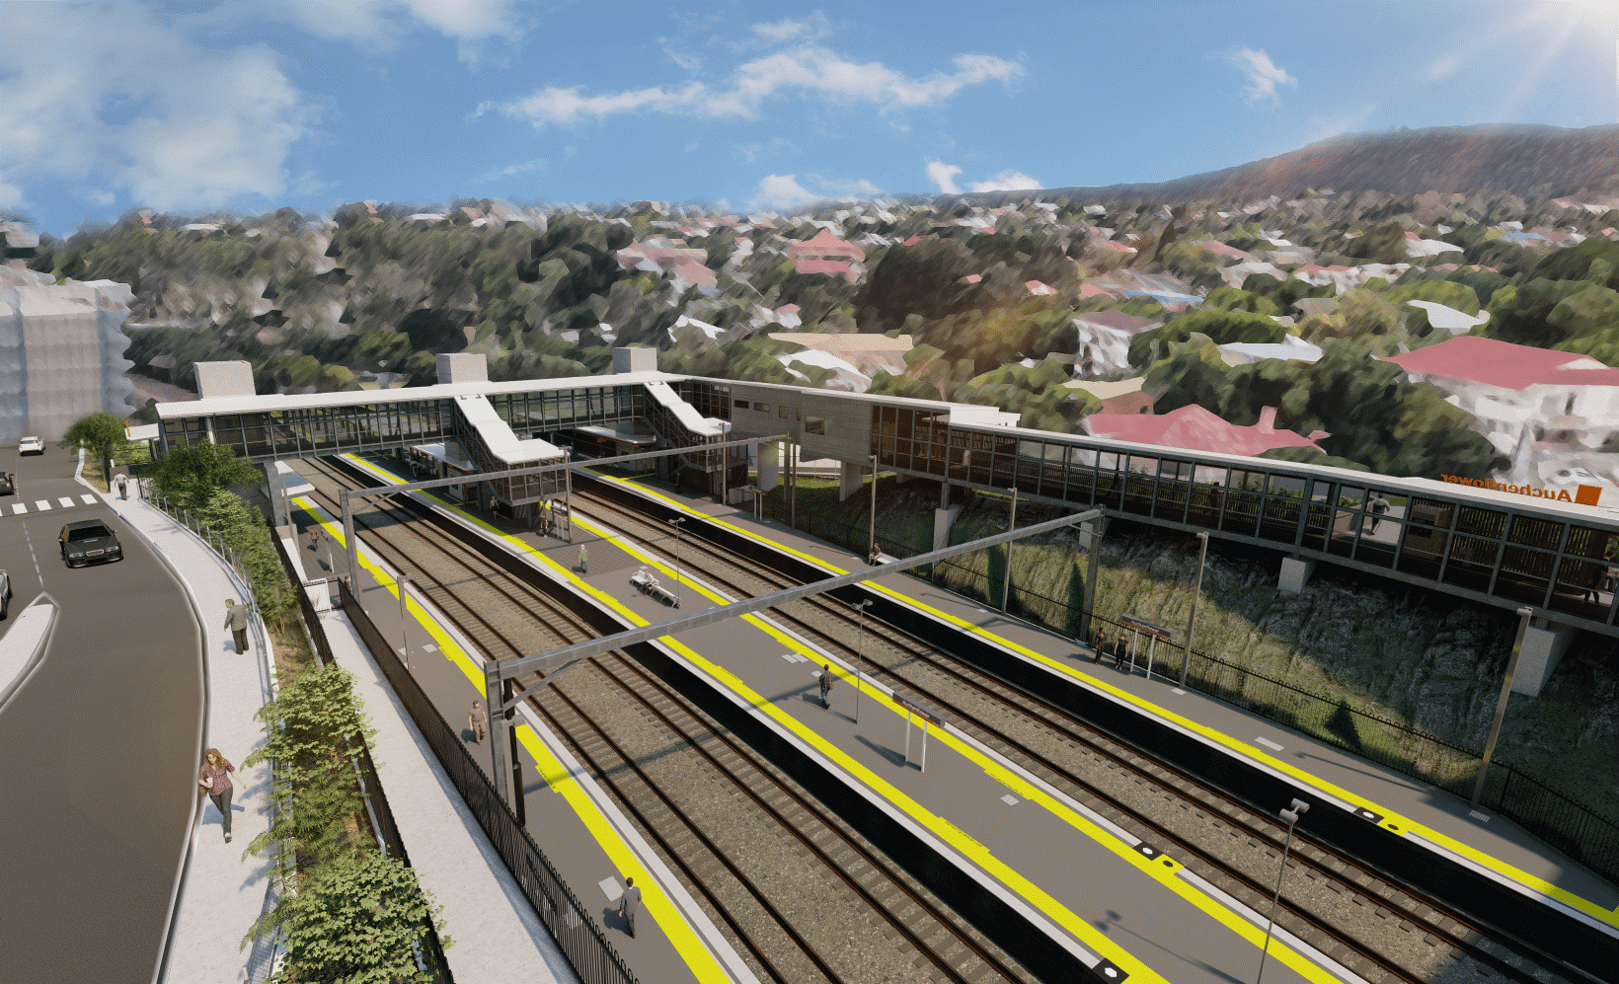
Auchenflower station accessibility upgrade

WORKS NOTICE

Pedestrian crossing – Lang Parade
For your safety, please follow all directional signage and cross only at the marked path, using designated pedestrian refuges.
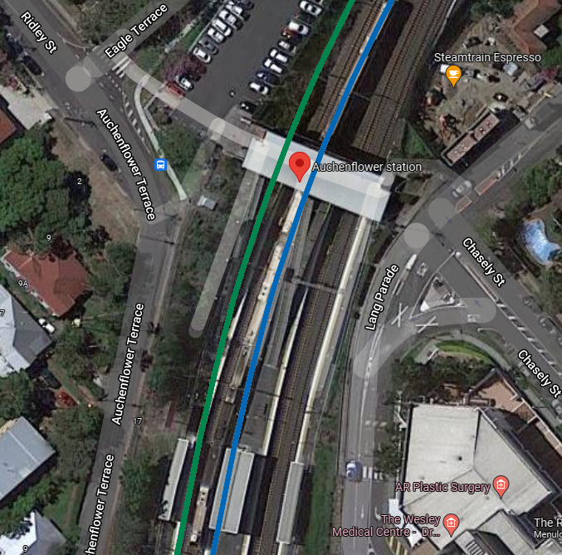
Work zone – no access

Recommended crossing
Concourse closing 20 March 2022
Station carpark – TEMPORARILY CLOSED
New crossing opening 20 March 2022

For more information, please contact the project’s community team on free call 1800 722 203 or email stationsupgrade@qr.com.au

