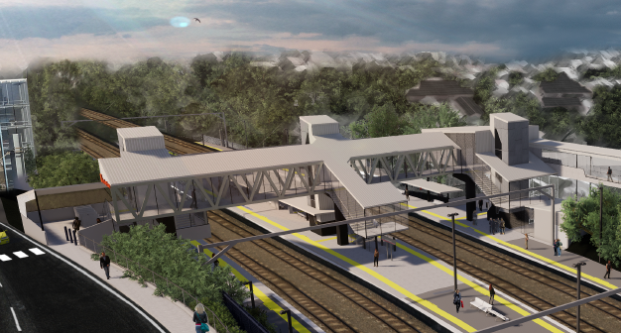

**Auchenflower station accessibility upgrade**

**PROJECT UPDATE – DECEMBER 2020**

**The Auchenflower station accessibility upgrade is part of the State Government’s investment to upgrade stations across the South East Queensland network, making them accessible for all customers.**

**Project progress**

Works recently undertaken at Auchenflower include:

* mobilisation of plant/equipment to platform work zone
* foundations piling (drilling) works – future raised platform sections (all platforms)
* commencement of foundations for new lift shaft and bridge structures.

**Upcoming works**

In the coming weeks, the following activities will be undertaken:

* footing works for new waiting shelters
* geotechnical investigations for new retaining structures, lifts shafts and bridge structures
* ongoing works for new footbridge and lift foundations
* ongoing station design activities (off-site).

Please take care around the work zones.

Project works on site will shut down for the Christmas and New Year period for two weeks from Friday 18 December 2020.

We wish you all a safe and happy festive season.

# 

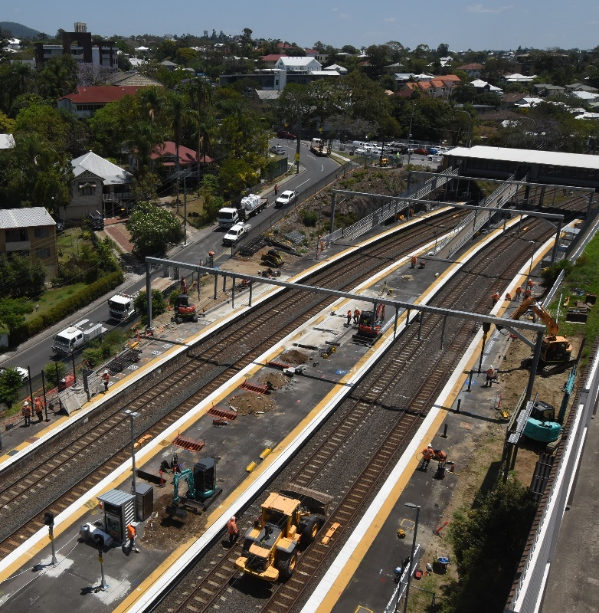

# Construction impacts

# During works, construction activities may involve:

* changed parking and traffic conditions for safety
* noise associated with heavy machinery
* temporary changes to access paths throughout the station precinct and surrounding areas
* relocated ticketing equipment and platform facilities
* increased vehicle movements near works
* mobile lighting towers for night works.

# Normal working hours are 6.30am to 6.30pm, Monday to Saturday.

# The local community will be given advance notification of construction activities likely to cause impacts, including after hours work (nights, Sundays and public holidays, if required).

# Thank you for your patience and cooperation as we build you a better Auchenflower station.

# Contact us

# For more information, to provide feedback or to be added to the project’s opt-in distribution list for email updates:

# Phone: 1800 722 203 (free call)

# Email: stationsupgrade@qr.com.au

# Website: queenslandrail.com.au