

**Auchenflower station accessibility upgrade**

**PROJECT UPDATE – JANUARY 2021**

**The Auchenflower station accessibility upgrade is part of the State Government’s investment of more than $500 million to upgrade stations across the South East Queensland network, making them accessible for all customers.**

**Project progress**

Works recently undertaken at Auchenflower include:

* site excavations
* footing works for new waiting shelters
* geotechnical investigations for new retaining structures, lifts shafts and bridge structures
* traffic changes near hospital carpark and closure of section of footpath and pedestrian crossing, Lang Parade (pictured at right)
* ongoing works for new footbridge and lift foundations.

**Upcoming works**

In the coming weeks, the following activities will be undertaken:

* overhead line and track works (late January)
* piling (foundations) for platform and bridge structures
* stormwater and sewer excavations
* platform works
* ongoing station design activities (off-site).

Please take care around the work zones.

# 

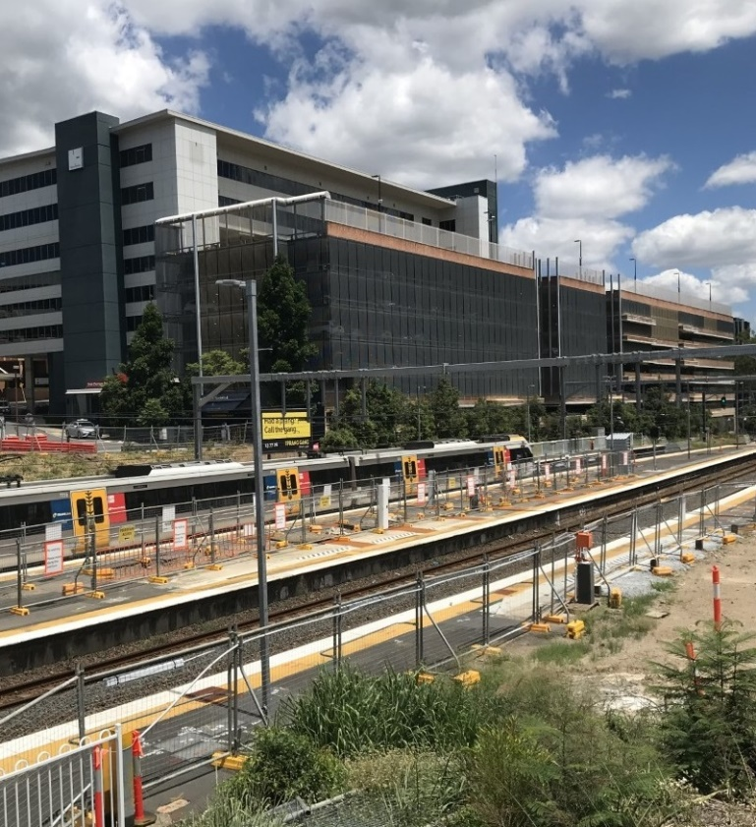

# Construction impacts

# During works, construction activities may involve:

* changed parking and traffic conditions for safety
* noise associated with heavy machinery
* temporary changes to access paths throughout the station precinct and surrounding areas
* relocated ticketing equipment and platform facilities
* increased vehicle movements near works
* mobile lighting towers for night works.

# Normal working hours are 6.30am to 6.30pm, Monday to Saturday.

# The local community will be given advance notification of construction activities likely to cause impacts, including after hours work (nights, Sundays and public holidays, if required).

# Thank you for your patience and cooperation as we build you a better Auchenflower station.

# Contact us

# For more information, to provide feedback or to be added to the project’s opt-in distribution list for email updates:

# Phone: 1800 722 203 (free call)

# Email: stationsupgrade@qr.com.au

# Website: queenslandrail.com.au