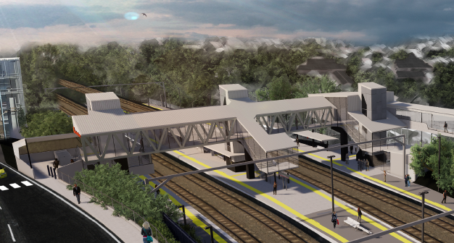

**Auchenflower station accessibility upgrade**

**PROJECT UPDATE – MAY 2020**

**The Auchenflower station accessibility upgrade is part of the State Government’s $357 million investment to upgrade stations across the South East Queensland network, making them accessible for all customers.**

**About the project**

The Auchenflower station accessibility upgrade will deliver improved station facilities, including raised platforms at the assisted boarding point, a new footbridge, lifts and improved accessible parking, so all customers can travel without barriers.

Main construction is expected to commence in the second half of 2020.

**Project progress**

The following activities have been undertaken recently, in preparation for future construction:

* ongoing early works – overhead infrastructure installation and modifications
* ongoing station upgrade design
* ongoing community engagement.

**Upcoming works**

In the coming weeks, customers and community can expect to see the following activities:

* continuing early works
* overhead line infrastructure activities
* track works.

# 

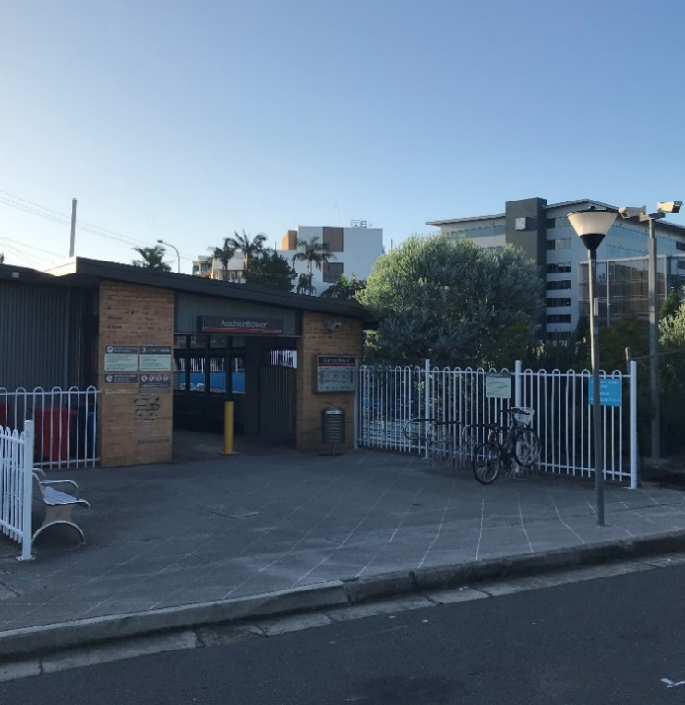

# Construction impacts

# During works, construction activities may involve:

* changed parking and traffic conditions for safety
* noise associated with heavy machinery
* temporary changes to access paths throughout the station precinct and surrounding areas
* increased vehicle movements near works
* mobile lighting towers for night works.

# Normal working hours are 6.30am to 6.30pm, Monday to Saturday.

# The local community will be given advance notification of construction activities likely to cause impacts, including after hours work (nights, Sundays and public holidays, if required).

# We thank you for your patience and cooperation as we build you a better Auchenflower station.

# Contact us

# For more information, to provide feedback or to be added to the project’s opt-in distribution list for email updates:

# Phone: 1800 722 203 (free call)

# Email: stationsupgrade@qr.com.au

# Website: queenslandrail.com.au