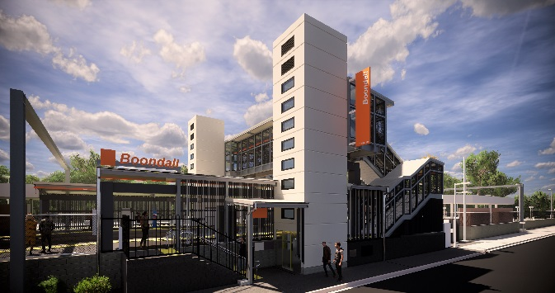
Boondall station accessibility upgrade

PROJECT UPDATE – DECEMBER 2019

The Boondall station accessibility upgrade is part of the State Government’s $357 million investment to upgrade stations across the South East Queensland network, making them accessible for all customers.

Project progress
Activities undertaken recently at Boondall have included:
- electrical services
- asphalting ramp sections on platforms
- ongoing construction of western entry plaza, upgrade of footpath to platform 2 and lighting
- bicycle enclosure slab.

Upcoming works
In the coming weeks, customers and the community can expect to see the following activities:
- station entrance works and bus shelter – Aberdeen Parade
- signage installation – platforms and footbridge
- bicycle enclosure construction
- CCTV installation
- electrical works
- lift installation.

Please follow all directional signage and take care around the work zones
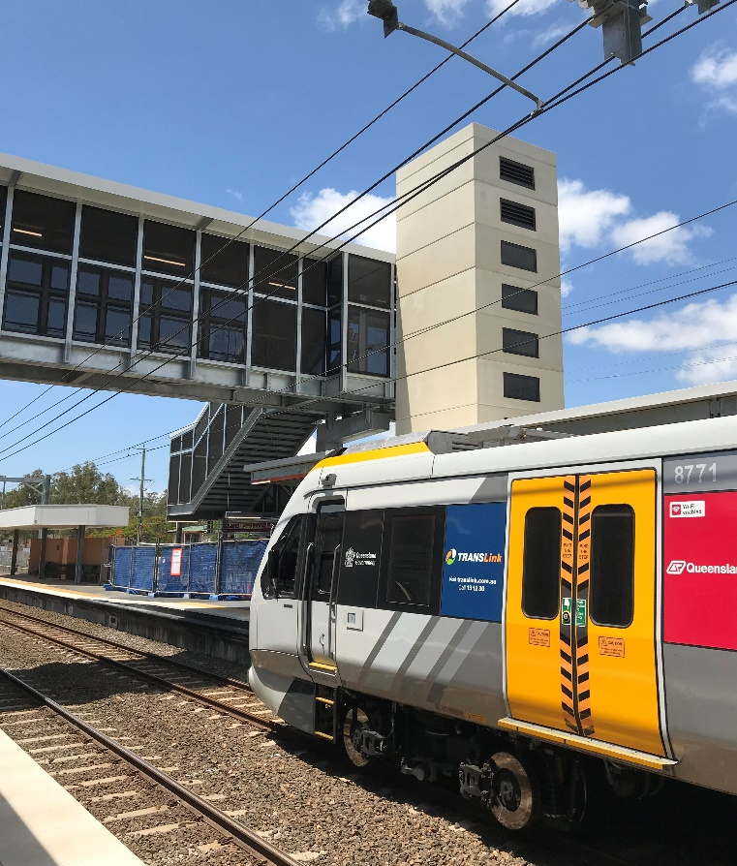

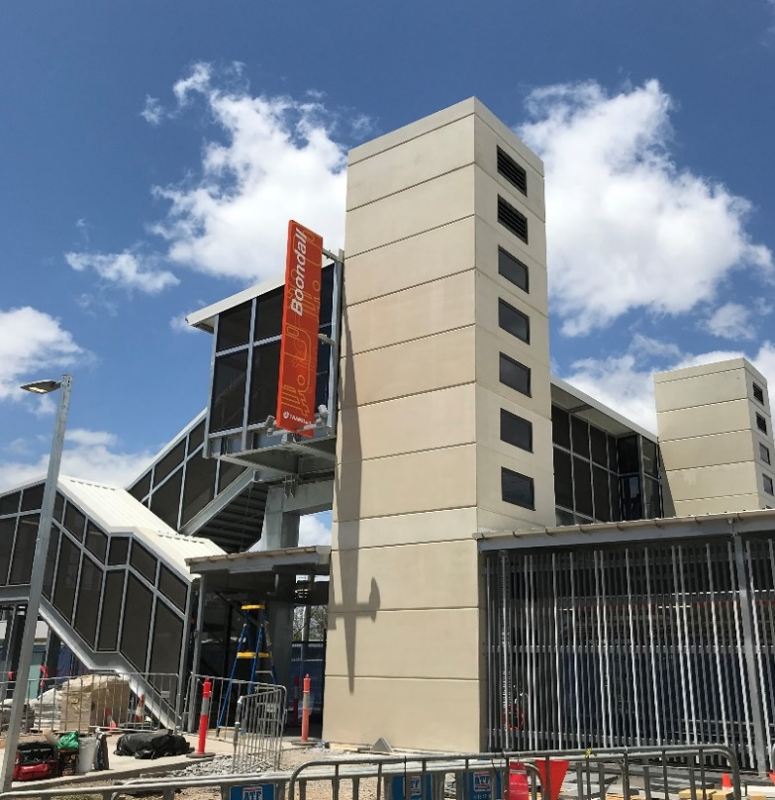

p

Construction impacts

Normal working hours are 6am to 5pm Monday to Saturday. Construction activities may involve:

noise associated with heavy machinery

temporary changes to station access paths

changed traffic/parking conditions (Aberdeen Parade)

increased vehicle movements near works

mobile lighting towers for night works.

Local residents will be given advance notification of construction activities likely to cause impacts, including after hours work (nights and Sundays, as required).

Thank you for your patience and cooperation as we work to improve your station.

Project activities will shut down briefly over the Christmas period. Works will resume in early January 2020.

Queensland Rail and the project team wish you season’s greetings and a safe and happy holiday period.

Contact us

For more information or to provide feedback:

Phone: 1800 722 203 (free call)

Email: stationsupgrade@qr.com.au

Website: queenslandrail.com.au

