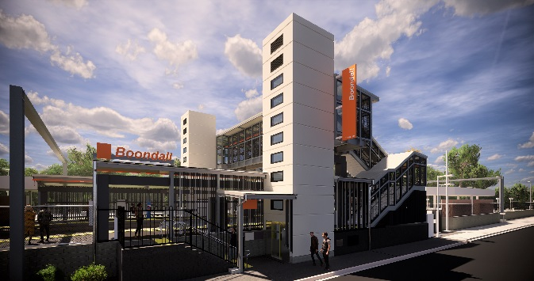
Boondall station accessibility upgrade

PROJECT UPDATE – JUNE 2019

Queensland Rail’s Boondall station accessibility upgrade is part of the program to upgrade stations across the South East Queensland network, making them accessible for all customers.

Construction impacts

Normal working hours are 6am to 5pm Monday to Saturday. Construction activities may involve:

noise associated with heavy machinery

temporary changes to station access paths

changed traffic/parking conditions (Aberdeen Parade)

increased vehicle movements near works

mobile lighting towers for night works.

Local residents will be given advance notification of construction activities likely to cause impacts, including after hours work (nights and Sundays, as required).

We thank customers and the community for your patience and cooperation as we work to improve your station.

Contact us

For more information or to provide feedback:

Phone: 1800 722 203 (free call)

Email: stationsupgrade@qr.com.au

Website: queenslandrail.com.au

Project progress
Activities undertaken recently at Boondall have included:
- concrete pour for footings for new footbridge and lift shaft – Aberdeen Parade
- construction of footbridge and stairs (offsite)
- construction of lift shaft segments (offsite)
- raised platform concrete pour – platform 2.

Upcoming works
In the coming weeks, customers and the community can expect to see the following activities:
- prepare footings for stairs to Aberdeen Parade
- pour concrete for lift wells – platforms 1 and 2
- prepare landings for stairs – platform 2
- construction of lift shaft to platform level – platforms 1 and 2
- crane lift to install new footbridge and stairs.

Please take care around the work zones.
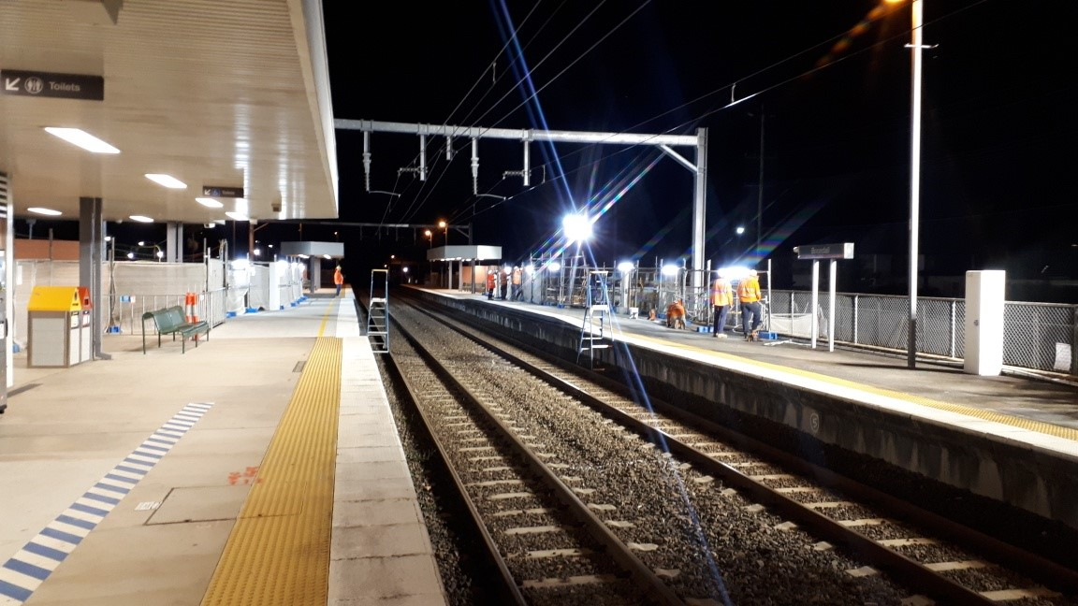

Platform raising (night works) during track closure, early June.

