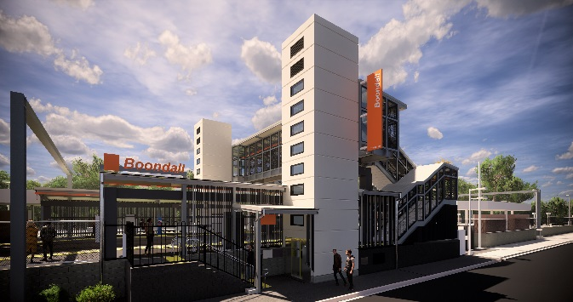

**Boondall station accessibility upgrade**

**PROJECT UPDATE – MARCH 2020**

**The Boondall station accessibility upgrade is part of the State Government’s $357 million investment to upgrade stations across the South East Queensland network, making them accessible for all customers.**

# Project progress

# Activities recently undertaken at Boondall included:

# ongoing station entrance, stairs and landscaping works

# installation of platform signage

# Aberdeen Parade footpath and asphalt works

# platform fencing

# painting – western entry walls.

# Upcoming works

# In the coming weeks, customers and the community can expect to see the following activities:

# minor works – station entrances and platforms

# completion of station signage

# light pole installation – bicycle enclosure

# installation of remaining lighting – platform 1.

# Please follow all directional signage and take care around the work zones.

# 

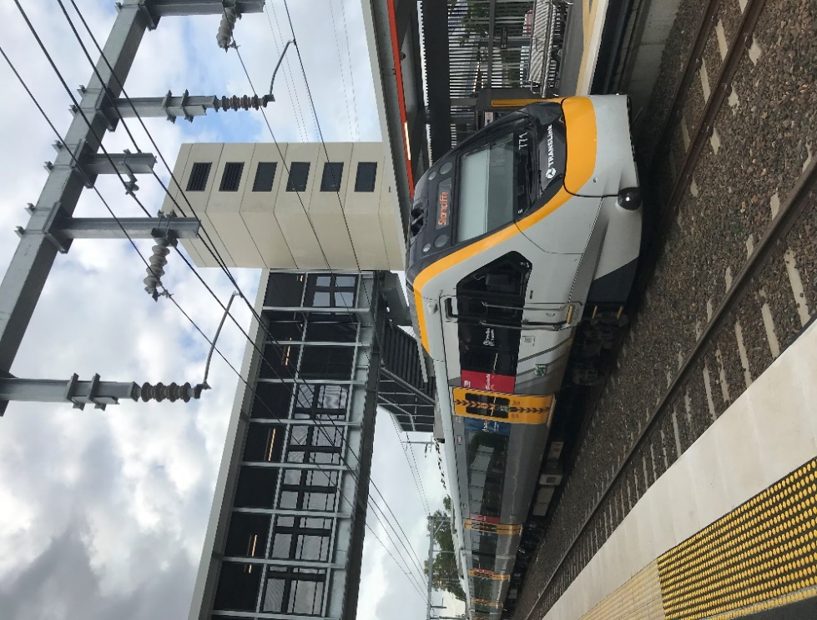

# Construction impacts

# Normal working hours are 6am to 5pm Monday to Saturday. Construction activities may involve:

# noise associated with heavy machinery

# temporary changes to station access paths

# changed traffic/parking conditions (Aberdeen Parade)

# increased vehicle movements near works

# mobile lighting towers for night works.

# Local residents will be given advance notification of construction activities likely to cause impacts, including after hours work (nights and Sundays, as required).

# Thank you for your patience and cooperation as we work to improve your station.

# Contact us

# For more information or to provide feedback:

# Phone: 1800 722 203 (free call)

# Email: stationsupgrade@qr.com.au

# Website: queenslandrail.com.au