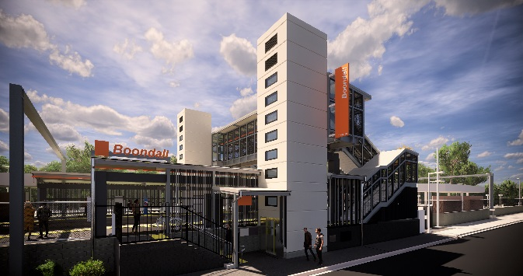
Boondall station accessibility upgrade

PROJECT UPDATE – NOVEMBER 2019

The Boondall station accessibility upgrade is part of the State Government’s $357 million program to upgrade stations across the South East Queensland network, making them accessible for all customers.

Project progress
Activities undertaken recently at Boondall have included:
- platform surface works and paving
- completion of new ticket window
- ongoing lift installation
- station entrance, kerbing and gutters (Aberdeen Parade)
- completion of safety screens on existing footbridge.

Upcoming works
In the coming weeks, customers and the community can expect to see the following activities:
- electrical services
- asphalting ramp sections on platforms
- construction of western entry plaza and upgrade of footpath to platform 2 and lighting
- platform works – signage, seating and ticketing equipment
- bike enclosure slab.
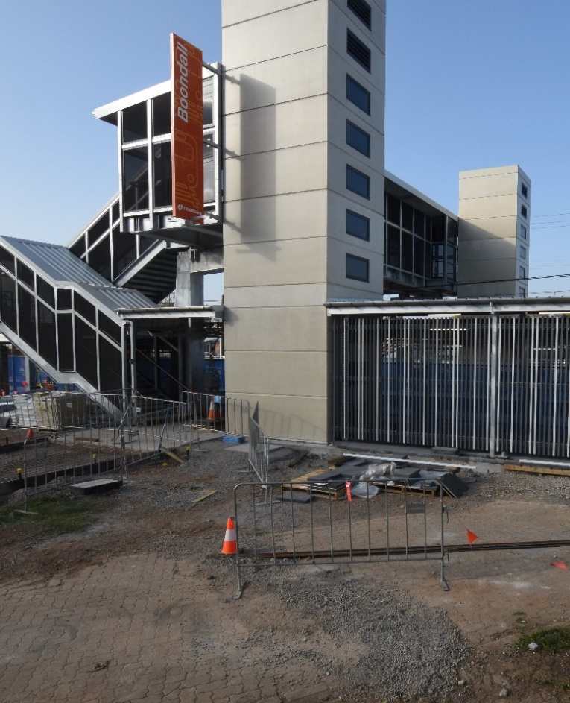

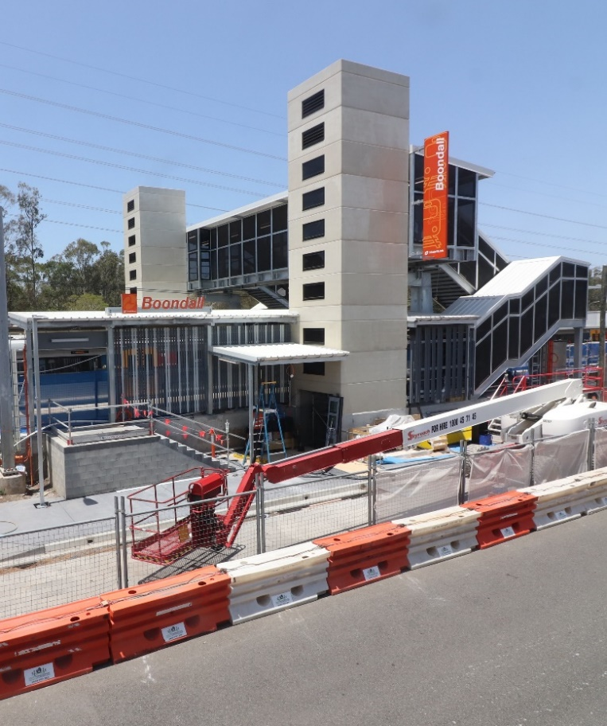

p

Construction impacts

Normal working hours are 6am to 5pm Monday to Saturday. Construction activities may involve:

noise associated with heavy machinery

temporary changes to station access paths

changed traffic/parking conditions (Aberdeen Parade)

increased vehicle movements near works

mobile lighting towers for night works.

Please take care around the work zones.

Local residents will be given advance notification of construction activities likely to cause impacts, including after hours work (nights and Sundays, as required).

We thank customers and the community for your patience and cooperation as we work to improve your station.

Contact us

For more information or to provide feedback:

Phone: 1800 722 203 (free call)

Email: stationsupgrade@qr.com.au

Website: queenslandrail.com.au

