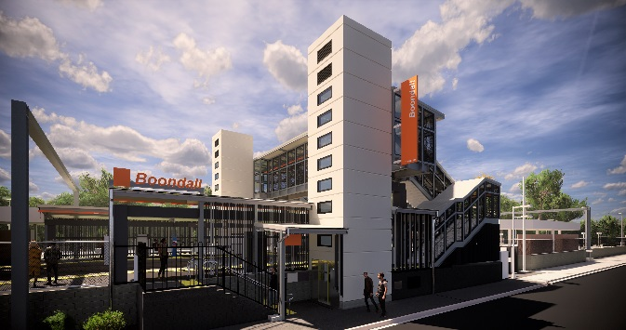
Boondall station accessibility upgrade

PROJECT UPDATE – SEPTEMBER 2019

Queensland Rail’s Boondall station accessibility upgrade is part of the program to upgrade stations across the South East Queensland network, making them accessible for all customers.

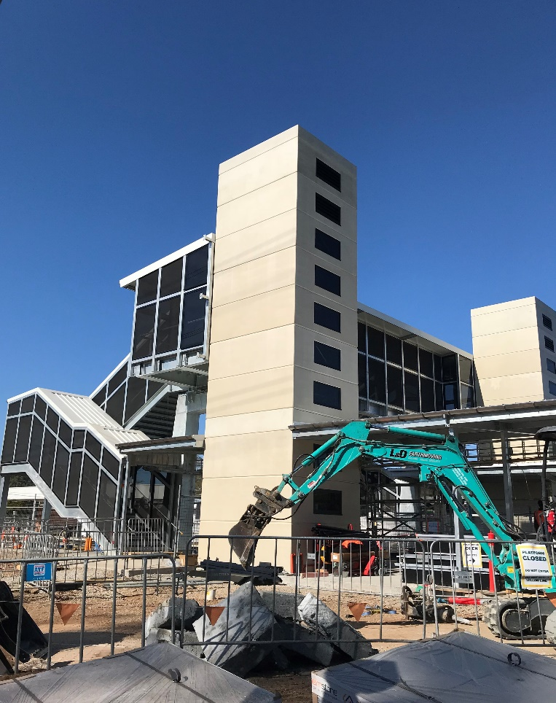
Footbridge and lift shafts, September 2019

Project progress
Activities undertaken recently at Boondall have included:
- extension of raised platform 1 (pictured, below)
- commencement of lift installation works
- platform shelter roofing
- installation of electrical switchboard and power connections.

Upcoming works
In the coming weeks, customers and the community can expect to see the following activities:
- platform surface works and paving
- ongoing lift installation
- installation of lighting and services in footbridge staircases
- station entrance, kerbing and gutters (Aberdeen Parade)
- installation of new ticket window.

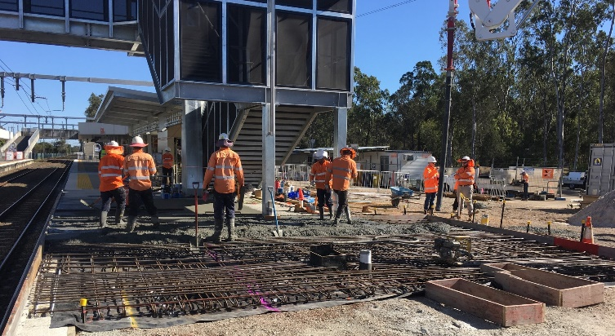
The station’s platforms will be closed for uninterrupted works from 11.30pm Friday 18 until 4am Monday 21 October. Rail services will not stop at Boondall during this time. Half-hourly shuttle services will take customers to North Boondall to connect with all services (allow an additional 30 minutes’ travel time).
Platform raising, prior to final surfacing works

Construction impacts

Normal working hours are 6am to 5pm Monday to Saturday. Construction activities may involve:

noise associated with heavy machinery

temporary changes to station access paths

changed traffic/parking conditions (Aberdeen Parade)

increased vehicle movements near works

mobile lighting towers for night works.

Please take care around the work zones.

Local residents will be given advance notification of construction activities likely to cause impacts, including after hours work (nights and Sundays, as required).

We thank customers and the community for your patience and cooperation as we work to improve your station.

Contact us

For more information or to provide feedback:

Phone: 1800 722 203 (free call)

Email: stationsupgrade@qr.com.au

Website: queenslandrail.com.au

