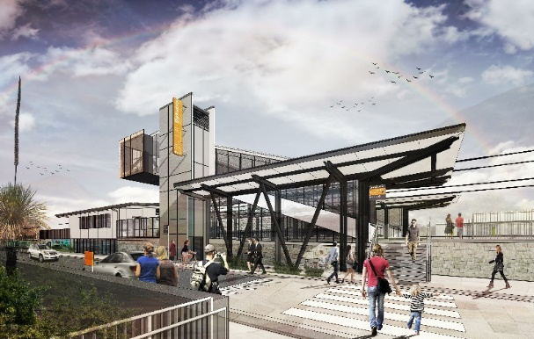

**Dakabin station accessibility upgrade**

**PROJECT UPDATE – AUGUST 2020**

**The Dakabin station accessibility upgrade is part of the State Government’s $357 million investment to upgrade stations across the South East Queensland network, making them accessible for all customers.**

**Proposal to temporarily close Thompson Road for construction (up to nine months)**

Queensland Rail’s initial approach was to deliver the station upgrade and carpark while maintaining through traffic on Thompson Road. However, in the months since main construction commenced, reports of **unsafe public motorist and pedestrian behaviour around the work zone** has prompted us to seek an alternative delivery method.

Some motorists are stopping within the traffic-controlled zone for customer drop-off near closed station entrances, limiting visibility and leaving pedestrians without a safe path to the station.

**For the safety of the public and workers,** Queensland Rail is proposing an **extended closure of Thompson Road to vehicles through the station precinct, for a period of between five and nine months** (site conditions permitting).

This road closure would involve **traffic diversions via Ann Street/Marsden Road/Alma Road** (see over). Safe, north-south pedestrian access through the site to the station would be maintained.

The closure would enable the contractor to **deliver critical elements of the program in a safe environment**, isolated from through traffic. It will also allow a more efficient realignment of Thompson Road to accommodate the new carpark design.

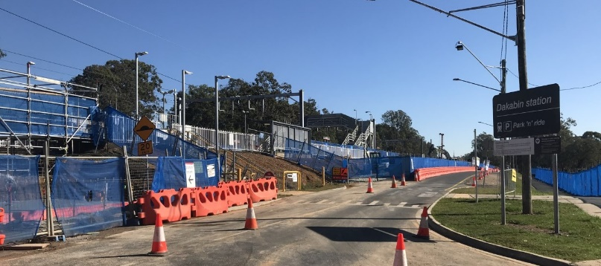

**Project progress**

Works undertaken recently at Dakabin include:

* foundations – lift shafts and bridge footings
* off-site construction of new footbridge, stairs and lift shaft components
* water main and sewer works
* earthworks – Thompson Road and carpark.

**Upcoming works**

In the coming weeks, the following project activities will be undertaken:

* delivery and assembly of footbridge components on-site (Narangba Road side of station)
* installation (crane lift) of footbridge – weekend track closure day works, 29 and 30 August
* ongoing carpark works.

# Construction impacts

# During works, construction activities may involve:

* changed parking and traffic conditions for safety
* noise associated with heavy machinery
* temporary changes to access paths throughout the station precinct and surrounding areas
* increased vehicle movements near works
* mobile lighting towers for night works.

# Normal work hours: 6.30am to 6.30pm, Mon-Sat.

# Thank you for your patience and cooperation while we build you a better Dakabin station.

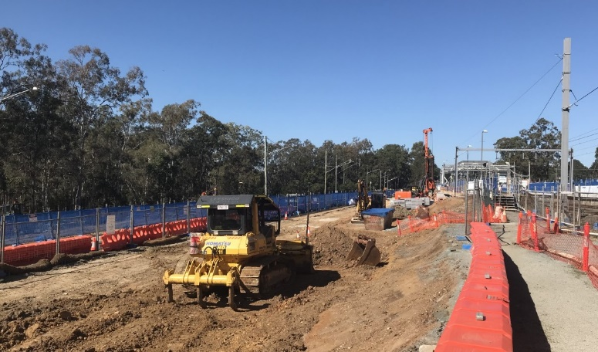

# Have your say

# Your views are important to us. You are invited to have your say about the proposed Thompson Road closure or any other aspect of project works. To provide feedback, contact the project team on:

Phone: **1800 722 203** (free call) Email: **stationsupgrade@qr.com.au** Website: **queenslandrail.com.au**

Page 2

**Proposed Thompson Road closure and detour**

**Approximately September 2020 to mid-2021**



*Map data © Google, 2020*

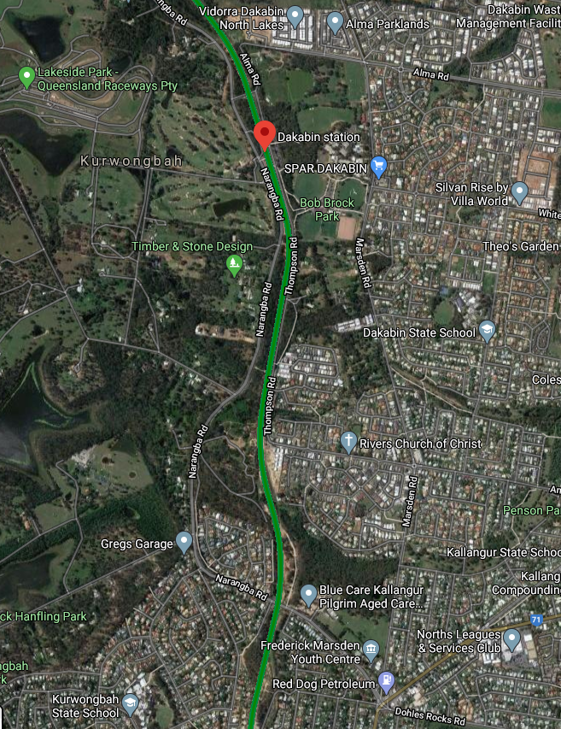

1111

1111

**Dakabin station and rail line**

**Temporary passenger set down zones**

**Pedestrian access maintained**

**Traffic diversion**

**Thompson Road closure – proposed up to nine months**

# Have your say

# Your views are important to us. You are invited to have your say about the proposed Thompson Road closure or any other aspect of project works. To provide feedback, contact the project team on:

Phone: **1800 722 203** (free call) Email: **stationsupgrade@qr.com.au** Website: **queenslandrail.com.au**

# Have your say

# Your views are important to us. You are invited to have your say about the proposed Thompson Road closure or any other aspects of project works. To provide feedback, contact the project team on:

Phone: **1800 722 203** (free call) Email: **stationsupgrade@qr.com.au** Website: **queenslandrail.com.au**