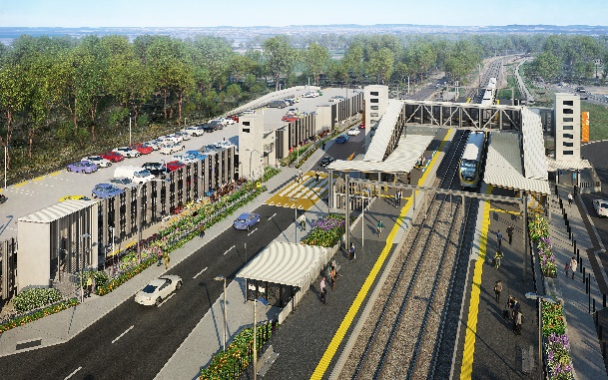

**Dakabin station accessibility upgrade**

**PROJECT UPDATE – AUGUST 2021**

**The Dakabin station accessibility upgrade is part of the State Government’s ongoing investment of more than $500 million to upgrade stations across the South East Queensland network, making them accessible for all customers.**

**Project progress**

Works undertaken at Dakabin in July include:

* station building fit-out (ongoing)
* carpark staircase construction
* ongoing lift installations – station and carpark
* Thompson Road stormwater and in-ground services installations
* testing and commissioning of new electrical main distribution board.

**Upcoming works**

In the next month, the following activities will be undertaken:

* continuing fit-out of station building and carpark
* ongoing lift installations – station and carpark
* Thompson Road and footpath subgrade installation
* construction of new bicycle enclosure
* embankment works – near platform 1
* drainage installation – Narangba Road slip road
* changes to pedestrian access throughout the precinct.

# Please take care around the work zones.

# 

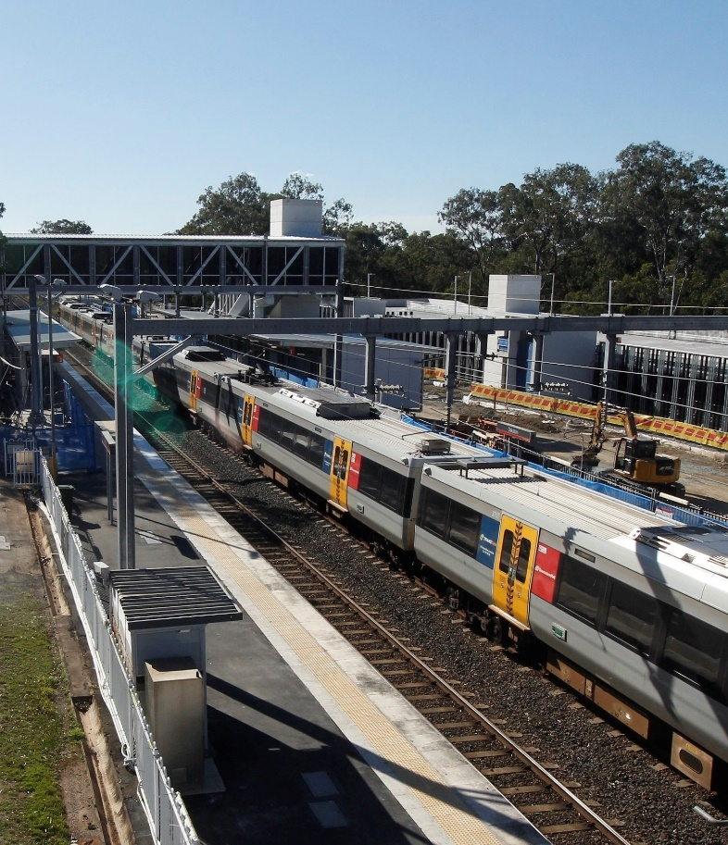

# Construction impacts

# During works, construction activities may involve:

* changed parking and traffic conditions for safety
* noise associated with heavy machinery
* temporary changes to access paths throughout the station precinct and surrounding areas
* increased vehicle movements near works
* mobile lighting towers for night works.

# To facilitate the completion of the multi-storey carpark, Thompson Road will be closed to vehicles through the station precinct until Thursday 30 September 2021.

# Customer access to Dakabin station will be maintained, with temporary customer kiss’n’ride zones on Narangba Road (south of the station, opposite Lakeside Road) and at each end of the Thompson Road closure (north, near Alma Road and south, near the temporary station entrance).

# Normal working hours are 6.30am to 6.30pm, Monday to Saturday. The local community will be given advance notification of construction activities likely to cause impacts, including after hours work (nights, Sundays and public holidays, if required).

# Thank you for your patience and cooperation while we build you a better Dakabin station.

# Contact us

# For more information, to provide feedback or to be added to the project’s opt-in distribution list for email updates:

# Phone: 1800 722 203 (free call)

# Email: stationsupgrade@qr.com.au

# Website: queenslandrail.com.au