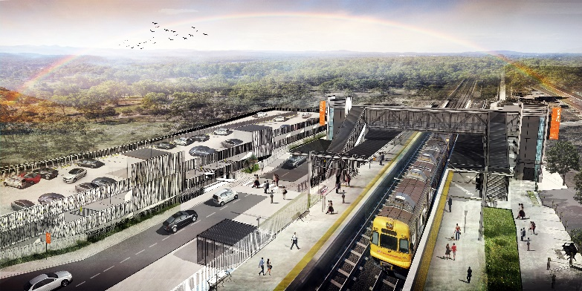

**Dakabin station accessibility upgrade**

**PROJECT UPDATE – DECEMBER 2019**

**The Dakabin station accessibility upgrade is part of the State Government’s $357 million program to upgrade stations across the South East Queensland network, making them accessible for all customers.**

**About the project**

The Dakabin station accessibility upgrade will deliver improved station facilities, so all customers can travel without barriers.

These improvements are designed to help customers achieve independent accessibility, with a new primary path of travel providing access to all train platforms independently via paths, ramps or lifts – without the need to use stairs.

Features of the accessibility upgrade include:

* a new pedestrian footbridge with lift access
* raised platform sections at assisted boarding points
* improved accessible parking
* upgraded hearing augmentation loops and tactile platform surfaces
* upgraded CCTV and station lighting
* new wayfinding and platform signage
* new bicycle enclosure and facilities.

A new multi-storey parking facility will replace the existing Thompson Road carpark and will be delivered concurrently with the station accessibility upgrade.

The project will double the station’s formal parking capacity to around 350. The new parking facility will provide additional accessible parking, some spaces to accommodate larger vehicles (such as SUVs or 4WDs) as well as dedicated spaces for small cars and motorbikes.

**Project status**

In recent months, Queensland Rail has completed concept designs and undertaken preliminary works, including the relocation of overhead line infrastructure, in preparation for main construction, which is expected to commence in mid-2020.

John Holland Pty Ltd has been appointed to deliver the detailed design and construction phases of the upgrade at Dakabin station. John Holland is currently working with Queensland Rail on accessibility upgrades at Strathpine, Morayfield and Boondall, having previously delivered upgrades at Alderley and Newmarket.

# 

*Concept design – subject to change*



**Parking at Dakabin station**

Parking at Dakabin station is currently over capacity, with more than 150 additional vehicles parking in Thompson and Narangba Roads.

The program of early works includes the progressive closure of the Thompson Road carpark in early 2020, ahead of main construction of the multi-storey carpark, commencing mid-year.

During traffic counts at Dakabin station and surveys on the Redcliffe Peninsula line, Queensland Rail found that a significant number of Dakabin customers travel from other locations such as the North Lakes area.

With the anticipated pressures on parking during construction, we strongly encourage customers to consider travelling from other stations with greater parking capacity, where possible. For example, Murrumba Downs has weekday capacity and may be a viable short-term alternative for some Dakabin customers.

***DID YOU KNOW?***

***With the same service frequency, switching from Dakabin (Caboolture line) to Kallangur (Redcliffe Peninsula line) means less than 10 minutes’ additional travel time to Central station.***

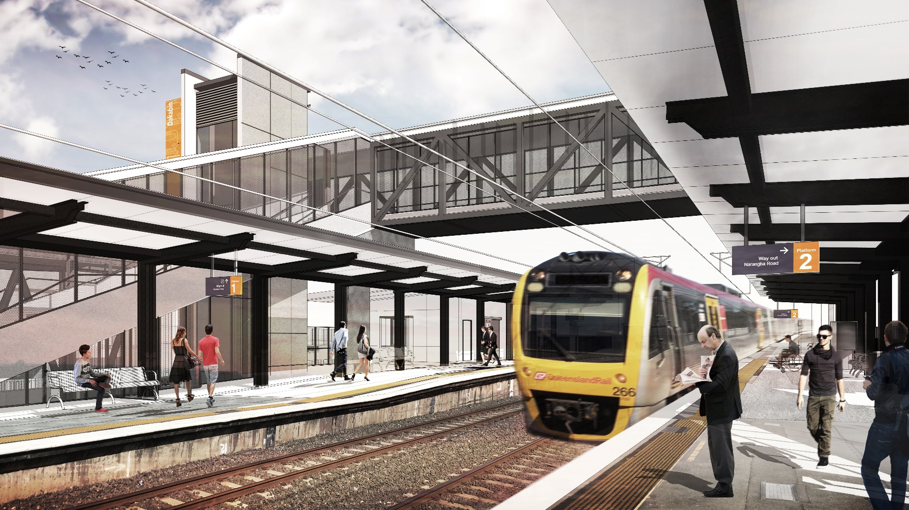

*Concept design – subject to change*

# Dakabin station will continue to operate throughout construction, except for short off-peak closures or around-the-clock works during planned track closures.

# The local community will be given advance notification of construction activities likely to cause impacts, including after hours work (nights, Sundays and public holidays, if required).

More information about the construction schedule and anticipated impacts will be available prior to the start of main construction.

# We thank you for your patience and cooperation as we work to build you a better Dakabin station.

# Keeping you informed

# Queensland Rail is committed to keeping you informed about our progress.

# Queensland Rail will be regularly delivering a comprehensive program of activities to inform you of the changes that may affect you, including the construction program when it is finalised.

# To be added to the project’s opt-in distribution list for email updates, please contact us at the email address below.

# Contact us

# For more information or to provide feedback:

# Phone: 1800 722 203 (free call)

# Email: stationsupgrade@qr.com.au

# Website: queenslandrail.com.au

***DID YOU KNOW?***

***In partnership with Queensland Rail, MBRC has made available 150 weekday parking spaces in nearby Bob Brock Park. This temporary arrangement will help alleviate the short-term customer parking impacts during works.***

# Changed parking conditions

While we recognise changes during construction will impact customer parking, these are necessary to safely deliver the upgrade. Moreton Bay Regional Council (MBRC) has already limited some kerbside parking.

We will continue to collaborate with the Department of Transport and Main Roads, TransLink and MBRC on alternative transport and customer parking arrangements.

# Construction commences in mid-2020

Wherever possible, upgrade work will be undertaken during normal, daytime working hours – 6am to 5pm, Monday to Saturday.

For safety, some works must be scheduled after hours or at times when there are fewer customers around the station precinct or when there are no trains running and the overhead power is switched off.