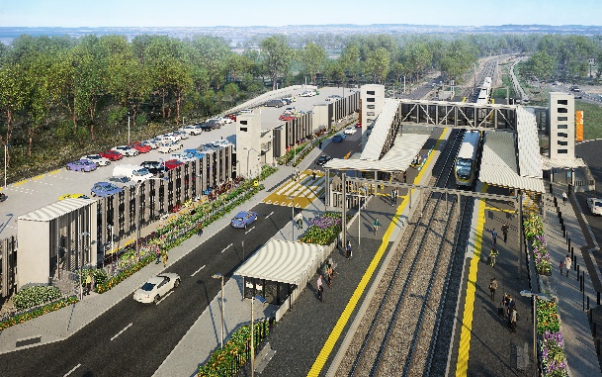

**Dakabin station accessibility upgrade**

**PROJECT UPDATE – DECEMBER 2020**

**The Dakabin station accessibility upgrade is part of the State Government’s investment to upgrade stations across the South East Queensland network, making them accessible for all customers.**

**Project progress**

Works undertaken recently at Dakabin include:

* carpark gabion retaining wall installation (pictured, right)
* station building structural steel manufacture (off-site)
* station lift shafts and stairs installation
* structural columns – carpark (pictured, below)
* opening of additional temporary access to station – northern (or Alma Road) end.

**Upcoming works**

In the coming weeks, the following project activities will be undertaken:

* continuing carpark works
* installation of carpark lift shaft and stairs
* ongoing Thompson Road realignment works
* water main and sewer works, drainage and footpath remediation.

# Please take care around the work zones.

# Project works on site will shut down for the Christmas and New Year period for two weeks from Friday 18 December 2020.

# We wish you all a safe and happy festive season.

# 

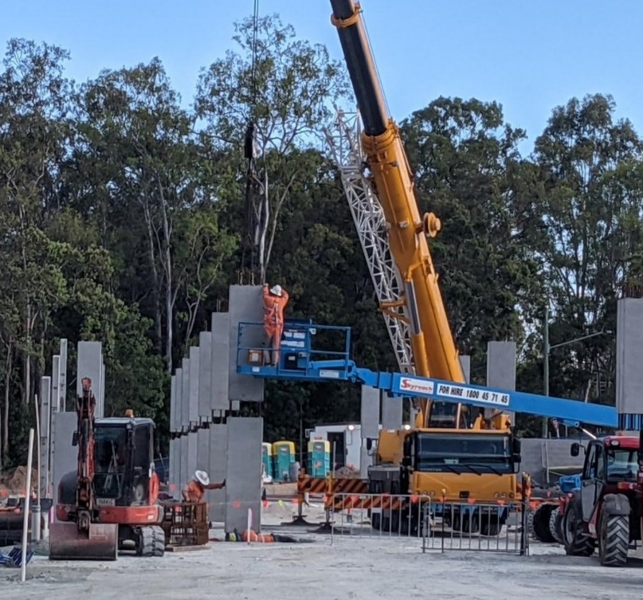

# Construction impacts

# During works, construction activities may involve:

* changed parking and traffic conditions for safety
* noise associated with heavy machinery
* temporary changes to access paths throughout the station precinct and surrounding areas
* increased vehicle movements near works
* mobile lighting towers for night works.

# Thompson Road will be closed to vehicles through the station precinct until approximately mid-2021.

# Customer access to Dakabin station will be maintained, with temporary customer kiss’n’ride zones on Narangba Road (south of the station, opposite Lakeside Road) and at each end of the Thompson Road closure (north, near Alma Road and south, near the temporary station entrance).

# Normal working hours are 6.30am to 6.30pm, Monday to Saturday. The local community will be given advance notification of construction activities likely to cause impacts, including after hours work (nights, Sundays and public holidays, if required).

# Thank you for your patience and cooperation while we build you a better Dakabin station.

# Contact us

# For more information, to provide feedback or to be added to the project’s opt-in distribution list for email updates:

# Phone: 1800 722 203 (free call)

# Email: stationsupgrade@qr.com.au

# Website: queenslandrail.com.au