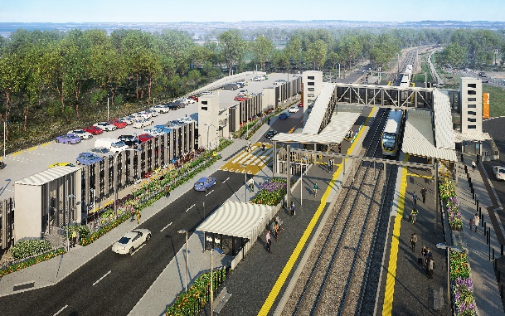

**Dakabin station accessibility upgrade**

**PROJECT UPDATE – DECEMBER 2021**

**The Dakabin station accessibility upgrade is part of the State Government’s ongoing investment of more than $500 million to upgrade stations across the South East Queensland network, making them accessible for all customers.**

**Project progress**

Works recently undertaken at Dakabin include:

* ticket office fit-out
* electrical works – light pole installation
* installation of *go* card and ticketing equipment on platforms 1 and 2
* final carpark line-marking
* kiss’n’ride (western carpark)
* landscaping (ongoing).

**Upcoming works**

In the coming weeks, customers and the community can expect to see the following activities:

* pre-opening inspections and commissioning of lifts
* reinstatement and opening of Thompson Road
* water and sewer connections
* fire systems commissioning
* commencement of ticket office operations
* continuing station entry works (western carpark)
* landscaping and finishing works
* completion of multi-storey carpark (early 2022).

# Please take care around the work zones.

**Season’s greetings**

We appreciate your patience and continued cooperation throughout works.

Project works on site will shut down for the Christmas and New Year period from Friday 17 December 2021, returning Tuesday 4 January 2022.

# We wish you all a safe and happy festive season.

# Construction impacts

# During works, construction activities may involve:

* changed parking and traffic conditions for safety
* noise associated with heavy machinery
* temporary changes to access paths throughout the station precinct and surrounding areas
* increased vehicle movements near works
* mobile lighting towers for night works.

# Normal working hours are 6.30am to 6.30pm, Monday to Saturday. The local community will be given advance notification of construction activities likely to cause impacts, including after hours work (nights, Sundays and public holidays, if required).

# Contact us

# For more information, to provide feedback or to be added to the project’s opt-in distribution list for email updates:

# Phone: 1800 722 203 (free call)

# Email: stationsupgrade@qr.com.au

# Website: queenslandrail.com.au