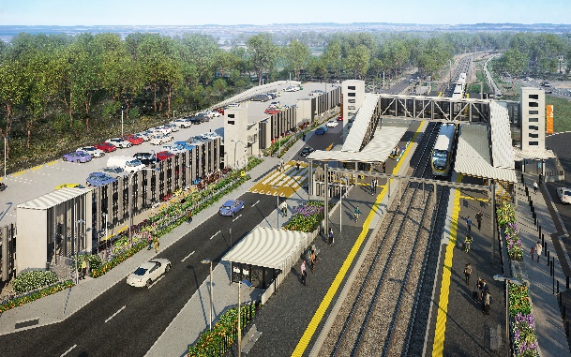

**Dakabin station accessibility upgrade**

**PROJECT UPDATE – FEBRUARY 2022**

**The Dakabin station accessibility upgrade is part of the State Government’s ongoing investment of more than $500 million to upgrade stations across the South East Queensland network, making them accessible for all customers.**

**Project progress**

Works recently undertaken at Dakabin include:

* demobilisation of project site compound buildings
* landscaping
* drainage works – western carpark and platform 2
* lighting activities – Thompson Road
* fit-out of new bicycle facilities
* installation ticketing equipment
* fencing and screening – platform 2.

**Upcoming works**

In the coming weeks, customers and the community can expect to see the following activities:

* opening kiss ’n’ ride facility – western carpark
* installation of corridor access gates
* installation of retaining walls, footpaths and fencing
* review of completed works and finalisation activities
* ongoing liaison with relevant state authorities for water and wastewater easement approvals
* opening of Thompson Road to vehicles (subject to approval)
* certification of fire systems and opening of multi-storey carpark.

# Please take care around the work zones.

# Construction impacts

# During works, construction activities may involve:

* changed parking and traffic conditions for safety
* noise associated with heavy machinery
* temporary changes to access paths throughout the station precinct and surrounding areas
* increased vehicle movements near works
* mobile lighting towers for night works.

# Normal working hours are 6.30am to 6.30pm, Monday to Saturday.

# The local community will be given advance notification of construction activities likely to cause impacts, including after hours work (nights, Sundays and public holidays, if required).

# Thank you for your patience while we build you a better Dakabin station.

# Contact us

# For more information, to provide feedback or to be added to the project’s opt-in distribution list for email updates:

# Phone: 1800 722 203 (free call)

# Email: stationsupgrade@qr.com.au

# Website: queenslandrail.com.au