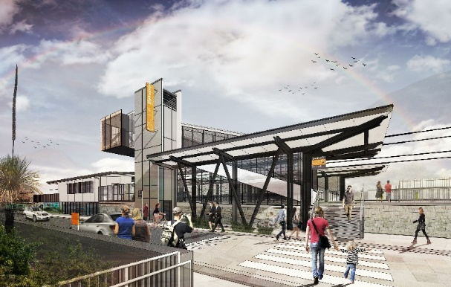

**Dakabin station accessibility upgrade**

**PROJECT UPDATE – JULY 2020**

**The Dakabin station accessibility upgrade is part of the State Government’s $357 million investment to upgrade stations across the South East Queensland network, making them accessible for all customers.**

**Project progress**

Works undertaken recently at Dakabin include:

* station foundation/piling works
* tree removal to enable carpark construction
* excavation of Thompson Road carpark (pictured below)
* temporary passenger drop-off and pick-up areas – Thompson Road and Narangba Road
* water and sewer infrastructure construction.

**Upcoming works**

In the coming weeks, the following project activities will be undertaken:

* foundations – lift shafts and bridge footings
* off-site construction of new footbridge, stairs and lift shaft components (ongoing)
* water main and sewer works (ongoing)
* continuing carpark works
* design of station building and other structures.

**Past student artwork available for return**

If you were involved in the 2011/12 positive pARTnerships art project at Dakabin station and would like your artwork returned, please contact the project team to arrange collection.

# 

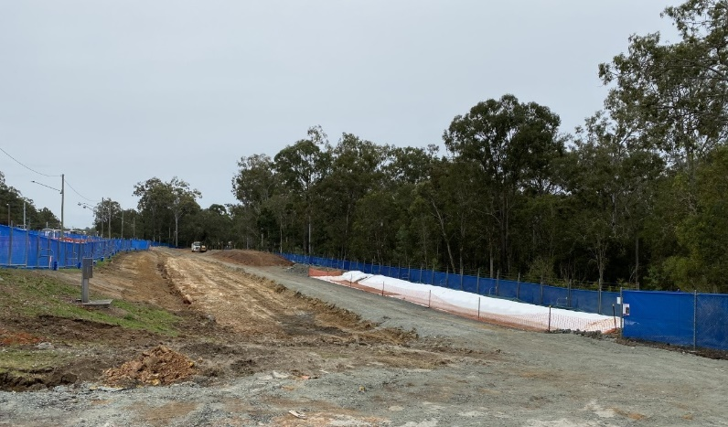

# Novel Coronavirus (COVID-19)

# Queensland Rail is committed to keeping essential rail services operating for Queenslanders during this challenging time and to do this, network maintenance and critical works must continue. To support workforce safety, Queensland Rail has implemented a number of additional control measures related to COVID-19 management. We will continue to take the necessary precautions to ensure the ongoing health and wellbeing of our team and the communities in which we operate.

# Construction impacts

# During works, construction activities may involve:

* changed parking and traffic conditions for safety
* noise associated with heavy machinery
* temporary changes to access paths throughout the station precinct and surrounding areas
* increased vehicle movements near works
* mobile lighting towers for night works.

# Normal working hours are 6.30am to 6.30pm, Monday to Saturday. The local community will be given advance notification of construction activities likely to cause impacts, including after hours work (nights, Sundays and public holidays, if required).

# Thank you for your patience and cooperation while we build you a better Dakabin station.

# Contact us

# For more information, to provide feedback or to be added to the project’s opt-in distribution list for email updates:

# Phone: 1800 722 203 (free call)

# Email: stationsupgrade@qr.com.au

# Website: queenslandrail.com.au